Servicenow for help desk

**Instructor Outline**

# Revision History

|  |  |
| --- | --- |
| **Date** | **Reason / Description of Change** |
| May 2022 | SLA Case List  My List Filters  Case Attachments  Attach Knowledge Articles  Filter Out / Matching in MyTravelport |
| April 2022 | Added process to contact multiple airlines from a Task.  Added process to reply to airline from a Task |
| March 2022 | Accept button required to change email, web cases to Open status  Location of the chat transcript in case workspace  Removed Escalation to ESP – EMEA Hardware Maintenance Vendor |

Table of Contents

Revision History 2

Instructor preparation 7

What is ServiceNow? 8

ServiceNow URLs - SLIDE 2 9

Accessing ServiceNow - DEMO 10

Platform User Interface 10

Agent Workspace – demo 11

Lists Tab 13

Accounts - DEMO 14

Contacts - DEMO 15

Case lists 16

Frequently-used lists 17

Working with cases lists 17

Blue highlight – cases last updated by the customer 21

Review: Cases lists- SLIDE 3 22

Case Life Cycle – SLIDE 4 23

Create Case: Overview – SLIDE 5 24

How customers create cases: MyTravelport and email 25

Create case from email 25

Create Case: MyTravelport – SLIDE 6 28

Internal User Cases – SLIDE 7 29

Create a case from MyTravelport – DEMO 30

View Cases in MyTravelport 31

Review: Cases created from MyTravelport and email – SLIDE 8 35

Interactions 36

Interactions – SLIDE 9 36

Interactions - eLearning 36

Create an interaction - demo 37

Select a contact for the case 39

Create a Contact – Demo 41

Link a contact to a CIDB – SLIDE 10 44

Link a Contact to a CIDB – DEMO 44

Interaction - more fields - Demo 46

Review: Interactions - Slide 11 47

Saved interaction 48

Cases 48

Interactions and Cases - SLIDE 12 48

Associate interaction to existing case 49

Create a new case from an interaction 50

Use templates to fill-in case fields - Demo 53

Case workspace fields - continued 54

Knowledge Results 56

Watch List 57

Notes area 58

Review: Templates, case fields - SLIDE 13 59

Creating a case – continued - DEMO 60

Propose Solution – First Call Resolution 61

Points to note about Solution Proposed cases 61

Attach a Knowledge Article to a case, Related Search Results - Demo 63

View attached knowledge articles from MyTravelport 65

Templates – Additional features 66

Resolution notes filled in by template 66

Unknown Caller template 66

Apply multiple templates 67

Create a template 68

Global and Wipro templates 70

Resolution Text – best practices – SLIDE 14 71

Templates – best practices – SLIDE 15 72

Review: Templates, case fields continued - SLIDE 16 73

More ServiceNow features 74

Customize the ServiceNow workspace 74

Settings menu 74

Expand / Collapse Details panels 76

Zoom Options 78

HTML / Rich text Editor 78

Customize the Agent Workspace: SLIDE 17 80

Claim Cases: Locate Unassigned Cases: SLIDE 18 81

Locate Unassigned Cases – DEMO 82

Assign the case 82

Assign case in case workspace 83

Web cases 83

Special Handling Notes 85

Special Handling Notes – slide 19 85

Search and Filter 87

Global Search - DEMO 90

Filter out / Show matching 90

Review: Search and Filter – SLIDE 20 93

Categorization 94

Categorization – SLIDE 21 94

Top Call Drivers to Categories – SLIDE 22 95

Categorization – DEMO 95

Chat 98

Chat with a Customer - DEMO 98

What happens if a chat isn’t answered? 102

Chat Notifications 103

Review: Chat - SLIDE 23 105

Notification Preferences – DEMO 106

Opt out of email notifications for cases assigned to my group 108

Multi-touch cases 109

Case Life Cycle – SLIDE 24 109

Pending Statuses and other options for working with multi-touch cases 110

Request Info from Customer - DEMO 111

Notes about case emails and attachments 112

Tags – DEMO 113

Related Lists 114

Related Lists – DEMO 114

Tasks – DEMO 115

Reply to a vendor from a task 119

Contact multiple vendors from a Task 120

Review: Tasks - SLIDE 25 121

Major cases – SLIDE 26 122

Major case – DEMO 122

Major Case - eLearning 123

Case Life Cycle: Resolution and Closure – SLIDE 27 124

Propose a Solution – SLIDE 28 125

Closure – SLIDE 29 126

Call Handling Best Practices 126

References – SLIDE 30 127

# Instructor preparation

* To simulate chat, it will be helpful to have access to **Impersonate User** on ServiceNow-test.  
  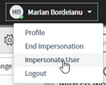
* Students will need to be able to access SN-prod, SN-test, MyTP-prod, MyTP-preprod
* Students should be registered for and have access to the following eLearning modules in the appropriate LMS:
  + ServiceNow Agent Workspace
  + ServiceNow Major Case for Help Desk
* For demos and practice requiring MyTravelport (such as **Create A New Contact**, **Create a case from MyTravelport**, etc.) be aware that login to MyTravelport-test does not always work. When this occurs, you will need to demo / practice these processes on the ServiceNow production site (<https://travelportprod.service-now.com/>).   
    
  When using the production site for training, please do the following to avoid creation of contacts on production and to minimize any impact to the help desk:
  + For the **Create a Contact** demo, do NOT create a contact on production.
  + Use an internal CIDB and test contact for demos and practice.
  + After class, propose solution on any test cases on you created on production.
* For the **Create A Contact** demo, you will need a contact that does not exist in ServiceNow.
* For **Link a Contact to a CIDB** demo, you will need a contact that exists in ServiceNow, but is not linked to the CIDB in the example.
* For **template creation** demo, make note of a case # you want to use as the basis of a template.

# What is ServiceNow?

**ServiceNow** is the application the help desk uses to manage issues that customers report.

Within ServiceNow, customer issues are tracked using **cases**. A case is the ServiceNow record used by agents to document, track, and resolve customer service issues. Cases keep all the all the information related to the customer’s issue bundled together, to make it easy for agents to see what has happened with resolving the customer’s issue.

Usually, you will create one case per issue. For example, if a customer calls because they can’t login, you will create a case for resetting their password. If they call back again in a few minutes with a new question about how to do something in Smartpoint, you will create a new, separate case for that issue.

Cases can be created in several ways, such as customers calling the Help Desk, when they submit a form from MyTravelport and when they send emails to certain mailboxes that have scripts that create cases.

## ServiceNow URLs - SLIDE 2

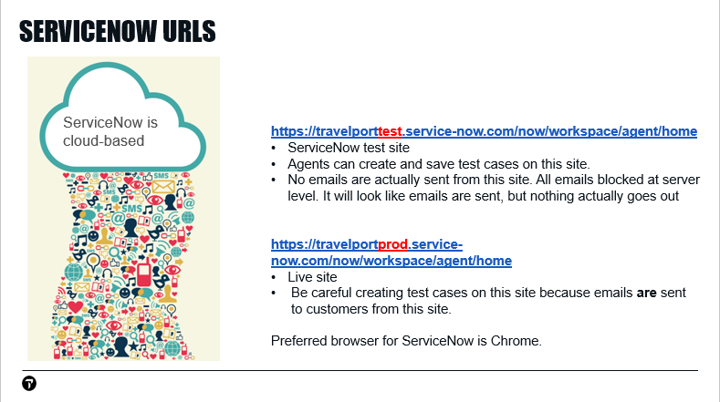

In the slide, we see some URLs you will be using to access ServiceNow.

## Accessing ServiceNow - DEMO

Since we will be creating test cases, we will begin by accessing the URL for the test ServiceNow site.

Access: <https://travelporttest.service-now.com>

## Platform User Interface

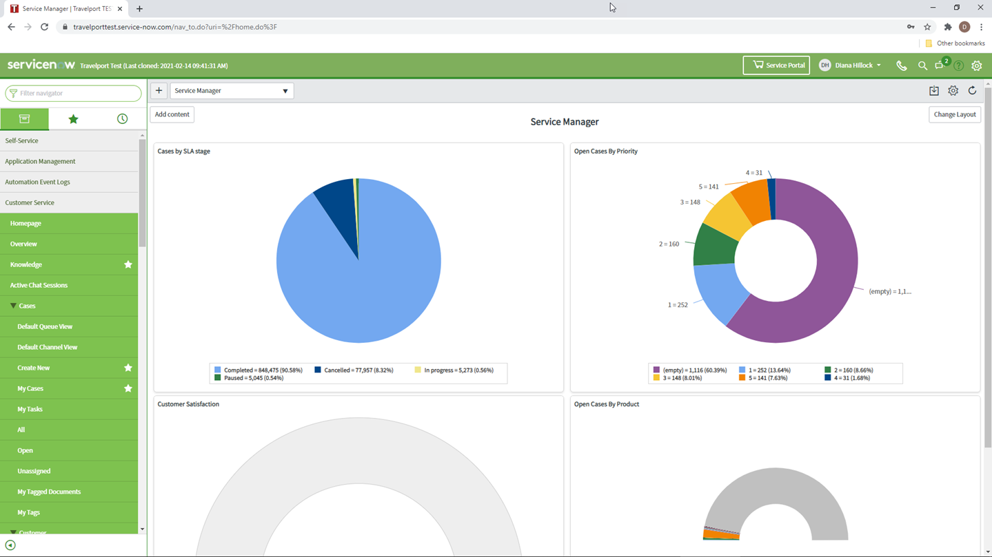

The display you initially see in ServiceNow is called the **Platform User Interface** or **Platform UI**. Most of your work with customers does **not** take place in this interface.

When helping customers, you will generally use the **Agent Workspace**. The Agent Workspace is an updated and enhanced version of ServiceNow that is faster and easier for agents to use.

## Agent Workspace – demo

|  |  |
| --- | --- |
|  | In the Platform UI, notice the **Filter Navigator** in the top left hand corner, just below the ServiceNow logo.  We can use this Filter Navigator option to access the Agent Workspace.  In Filter Navigator, type**: Agent Workspace** |
|  | A list of options with similar names appears.  Select **Agent Workspace Home.** |
|  | The Agent Workspace opens in a new browser tab.  The other tab is the Platform UI we saw before.  To go directly to the Agent Workspace, without needing to search in the Platform UI, use the URL in the previous slide:  <https://travelporttest.service-now.com/now/workspace/agent/home> |
|  | The icons you see in this display are determined by your ServiceNow profile. If you have a different profile than mine, your Agent Workspace home page may look different.  The tiles in the home page display are the various lists your team has access to.  The numbers on the tiles are the count of cases in each list. |
|  | In this example, the tiles are grouped by High Priority Cases, My Cases, and My Team’s Cases.  Starting on the left side of the display, we have:   * High Priority Cases - Cases that are assigned SLI 0 or 1 or that are SLA Breached. SLA Breached means the case has not been responded within the time that is required. * My Cases – Cases that are assigned to the agent. These are further broken down by:   + Cases that require attention by the agent   + Cases that have not been updated in 2 or more days   + Cases in Open status   + Cases in All statuses |
|  | On the right side of the display, we see cases assigned to the agent’s groups. These cases are further broken down by:   * Unassigned cases – cases that are not assigned to an agent * High-priority cases that are assigned SLI 0 or 1 * All cases in Open status that are assigned to the agent’s teams |
|  | Under My Teams’ Cases, select **Unassigned cases.** |
|  | Here is a list of cases that are assigned to the agent’s groups but have not yet been assigned to an agent.  If we were ready to start working another case, we could go to this list to select our next case to investigate. |
|  | The **House icon** and **Home tab** icon in the top left hand corner return to the home page.  Select the Home tab icon. |
|  | The **Lists** option appears below Home in the top left hand corner of the Navigator.  Select the **Lists** option. |

## Lists Tab

|  |  |
| --- | --- |
|  | Here is the Lists tab.  On the left side of the display, we see all Lists the agent can view.  Some of these are similar to the Tiles we saw on the home page, but here we have more options.  We can see that related lists are grouped. For example, lists related to Cases are in the Cases group.  Notice the **Customer** group. If we need detailed information about accounts or contacts, we can find that here. |
|  | In the **Customer** group, select the **Accounts list.** |

## Accounts - DEMO

|  |  |
| --- | --- |
|  | Here we have a list of all accounts. These are our customers’ companies.  To view details for an account, click a link in the **Customer Number** column. |
| Here we see some basic information for the account, such as country and email address.  **Scroll down to see more account details.** | |
|  | As we scroll down, we can see the account’s installation address and the email address for their sales manager.  If a customer asks you to copy their sales manager on emails for their case, this is where you can get their sales manager’s email address. |
| Also notice the row of tabs under the Account name.  These tabs can help you when you are assisting customers. For example, assume a customer is asking about a case their colleague raised earlier, but they don’t remember the case number. In this scenario, you could check the **Cases** tab to see all cases raised for the customer’s account. | |

## Contacts - DEMO

|  |  |
| --- | --- |
|  | Notice that the Account we viewed appears in a separate tab.  We can return to the Lists view by clicking the Lists tab.  Selectthe **Lists** tab**.** |
|  | Now, let’s look at the Contacts list.  Select **Contacts.** |
|  | When we view the Contacts list, notice the Account tab we were viewing earlier is still in the ribbon.  By letting you switch between tabs, ServiceNow makes it easy for you to find information to help our customers. |
|  | In the Name column, our customers’ names appear.  To view a contact record, select a link in the **Name** column. |
|  | On the Contact Details tab, we can scroll down to see basic information for the customer, such as their email, country, and preferred language.  Customers often do not remember which email they registered their account under. You can check this here. |
|  | Notice we have a Cases tab, where you can see all cases this customer has created.  If you are working on a case for a customer, you can look here to see if they have reported a similar issue previously. |

# Case lists

We have talked a little bit about cases, but what is a case exactly?

A **case** is the ServiceNow record used by agents to document, track, and resolve customer service issues. Cases help you bundle all the items related to the investigation to keep them organized and easy to find. We will look at cases in detail later in this training.

We’ve looked at lists for Accounts and Contacts in ServiceNow. To help you manage your cases, ServiceNow also provides case lists. For example, you can use case lists to view all your cases that are in a certain status or that have been updated by a customer.

## Frequently-used lists

|  |  |
| --- | --- |
|  | To return to our lists, we need to select the Lists tab in the ribbon or the Lists icon in the left toolbar. |
|  | Cases lists are grouped under the Cases heading.  Depending on your profile, you may have the following lists of cases:   * **My Cases**: Cases that are assigned to you * **My Open**: Cases that are assigned to you that are in Open statuses. Some examples of open statuses are cases pending a response from the customer or cases that are pending a response from the help desk. * **Unassigned for my groups**: Cases that are assigned to your groups that are not assigned to an agent. * **All**: All cases in open and closed status. |
|  | The SLA case lists let you see where your cases are in regard to the SLA. This is a good place to check if you have any cases that are SLA Breached. (SLA Breached means the case has not been responded within the time that is required.)  Team leads can also use the SLA > Open Cases list to monitor all Open cases with regard to SLA. |

## Working with cases lists

|  |  |
| --- | --- |
|  | Select the **Lists** tab. |
|  | Select the **All** list to view all cases that are in ServiceNow. |

If you have used Excel before, you might think of each list as being similar to an Excel spreadsheet, with rows and columns:

* Each **row** represents one case
* Each **column** represents one field on the case

|  |  |
| --- | --- |
|  | In the bottom ribbon, we see the number of cases in the list. |
|  | If we hover on a column header, we see 3 vertical dots. |
|  | We can select these 3 dots to display a menu.  The group by option allows you to group the records by specific fields, in this example, country.  **Select** **Group** **by** **Country Cod**e. |
|  | Here, the **Group by** option lets us see the number of cases for each country. |
|  | To remove the grouping, **select 3 dots > Ungroup.**  Although we showed grouping by country, you can use the 3 dots to group by any column heading. |
|  | Case numbers appear in the Number column. They begin with the letters “CS”.  Clicka case number. |
|  | The case opens in a new tab. We can easily return to the list by closing this tab or clicking the Lists tab.  Clickthe **X** to close the Case tab. |
|  | The display returns to the All cases list.  If we scroll to the right, notice some of the text is green. This green text means the text is a hyperlink.  You can click these hyperlinks to open the record for that field in a new tab. |
|  | You can sort the list by any column by clicking the column header.  The up and down arrows in the header tell you whether the list is sorted in ascending or descending order.  When you make changes to how a list displays, only you will see this list appear this way. No changes are made to the default list. |
|  | If we select the **3 dots** in a column header, notice there is also a Filter option. This option is context-sensitive for each column. |
|  | For example, if we only want to see cases for a certain country, we can select the **contains** option and fill-in the country we want to see. |
|  | We can apply multiple filters.  For example, in addition to filtering by country, we could also **filter** by date. |
|  | Notice the filter icon in the top right corner.  A number has appeared on this icon to alert us that the list is now filtered. |
|  | If we **click** the **filter icon**, we can see a list of filter conditions that are applied to the list. |
|  | If we want to return to the original list, we can **click** the **X** to remove a filter or **Restore defaults** to return to the original list. |
|  | If you use a filter frequently, you may want to save a list that has that filter applied, so you can use it again.  To save a filtered list, **select** the **gear** in the top right corner > **Save As**. |
|  | **Type** a name for the list and **click** Save. |
|  | The list is saved in the left toolbar > My Lists tab. |

## Blue highlight – cases last updated by the customer

When you are working with a case list, you will sometimes see the short description text has a blue highlight.

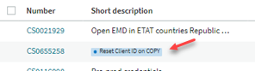

This highlight means the case was last updated by the customer. For example, if you had replied to a case to ask the customer for more information, you would see the blue highlight in the case list when the customer replies.

Let’s do a quick review of Lists.

## Review: Cases lists- SLIDE 3

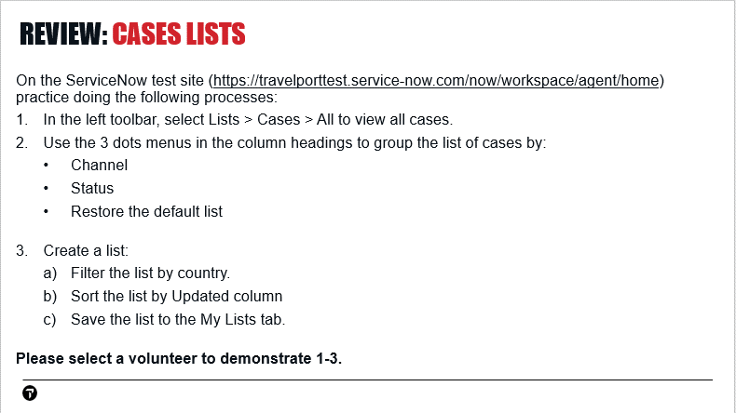

## Case Life Cycle – SLIDE 4

This slide shows an overview of the case life cycle.

Cases that originate from a phone call or chat start as **Interactions**. From these interactions, the help desk creates a new case or links the interaction to an existing case.

Cases that originate from MyTravelport forms or emails begin as cases rather than interactions.

All cases begin in a **New** state. In this state, an agent creates a case in ServiceNow or they may locate a case that was submitted directly by the customer

When creating the case, the agent documents details of the issue in the various case fields.

The case automatically changes to **Open** state when it is assigned to an agent or re-assigned to another group or agent. An exception to this is **FCR** or **First Call Resolution Cases** which go directly from **New** state to **Solution Proposed**.

**FCR** cases are cases in which the agent creates and proposes solution on the case in one edit, without saving the case before proposing solution.

After an agent solves the customer’s issue, they change the case to **Solution Proposed** status. While the case is in Solution Proposed status, the customer can re-open it for 10 calendar days. If they don’t re-open it within this time period, the case will permanently close.

## Create Case: Overview – SLIDE 5

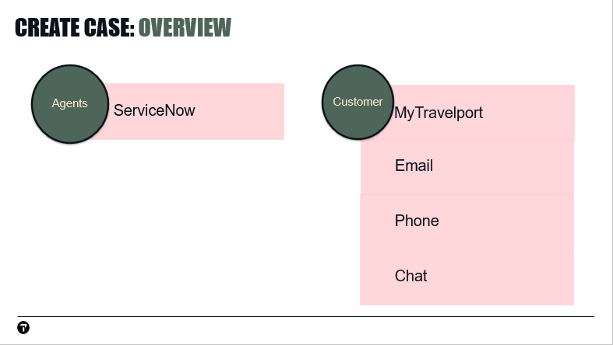

This slide shows how cases can be created by agents or customers.

**Agents:**

Agents create new cases in ServiceNow.

**Customers:**

Customers can create cases by submitting forms in MyTravelport. They can also send an email to the various helpdesks, which creates a case populated with information from the email**.** Customers who have chat available can create a case by selecting the Chat option in MyTravelport.

Customers can also call the help desk to have an agent create a case for them.

# How customers create cases: MyTravelport and email

Before we try creating cases in ServiceNow, let’s look at how customers can create cases for themselves in MyTravelport and by email.

## Create case from email

End user customers can create a case by sending an email to certain mailboxes at Travelport that have programming to automatically create a case from the email. A case is created with the with the sender’s email address as the contact for the case.

Let’s look at an example of a case created from email in ServiceNow.

|  |  |
| --- | --- |
|  | In ServiceNow, display the 3 dots menu for the **Channel** field.  The Channel field tells you how a case entered ServiceNow, such as phone or email. |
|  | The drop-down gives us a list of mailboxes where customers send their emails.  The mailboxes in this list have a script that automatically creates a case when an email is received. |
|  | Let’s filter the list to view cases that originated from the Galileo mailbox.  To uncheck all options, select **None.** |
|  | Select **Email: Galileo > Apply**. |
|  | The list is now filtered to show only cases that originated as emails sent to the Galileo mailbox.  Let’s view one of these cases and take a closer look at the email the customer sent to create the case.  Select a case number that is **New** status. |
|  | By default, the **Details** tab is selected. Details information appears in the left column.  The **Case Source** field confirms this case originated from an email. |
|  | If we scroll down in the left column, we see the **Short description** and **Description** fields.  The subject of the email the customer sent appears in the **Short description** field.  The body of the customer’s email appears under **Description**. |
|  | **Complete** the required fields, assign the case to yourself. |
|  | Save the case. |
|  | Notice that the case is still **New** status, even though we have saved it as assigned to an agent.  For email cases, we need to select the **Accept** button to enable these options. |
|  | Once Accept is selected, the status changes to **Open**. |

Some important points to note about cases created from emails:

In order for help desk mailboxes to create a case based on an email, the sender’s email address must be associated to a contact in MyTravelport.

What happens if a customer who does **not** have a contact in MyTravelport sends an email to help desk mailboxes? They receive an autoreply email with steps for them to create a contact in MyTravelport. This also creates the contact in ServiceNow.

Internal users cannot create a case by sending an email to the help desk mailboxes. This is working as designed because internal users are meant to create cases from MyTravelport rather than email.

## Create Case: MyTravelport – SLIDE 6

Customers and internal users can can submit cases or get help from MyTravelport.

Customers can also launch a live chat with a help desk agent, or fill out a form with their issue details, which automatically creates a case.

Internal users have access to the Raise a case option, but do not have access to live chat.

## Internal User Cases – SLIDE 7

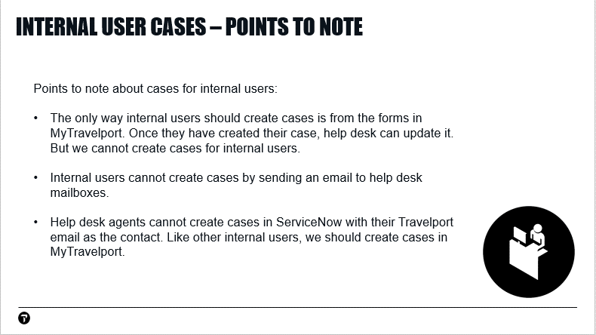

## Create a case from MyTravelport – DEMO

Let’s create a case in MyTravelport. Then, we will see how our case appears in ServiceNow.

|  |  |
| --- | --- |
|  | Begin by accessing the test MyTravelport site at:  <https://travelporttest.service-now.com/mytravelport_support>  If required to sign in, enter the credentials for your internal Travelport account. |
|  | To access the MyTravelport Support Portal, select **Help and resources** > **Travelport Support** |
|  | If we were actually looking for information, it would be a good practice to search for knowledge articles before creating a case.  To do that, we would enter our question in the search field at the top of the page.  For this example, let’s assume we’ve already searched and couldn’t find what we needed. |
|  | The chat icon in the lower right corner allows end user customers to chat with the help desk or raise a case after searching.  Internal customers can use the virtual agent functionality but cannot live chat with the Help Desk. |
|  | To create our case, we will scroll to the bottom of the page, to the **Raise a Case** Tile.  To view the forms, select **Open request**. |
|  | Select **Travelport Support Request.** |
| Fill-in the form with test information, then click **Submit**.  The response is our case number and a Thank You message with a link to My Cases.  Let’s make note of our case number, to make it easy to find. | |

## View Cases in MyTravelport

|  |  |
| --- | --- |
|  | Customers can see their cases from the **My Cases** list in MyTravelport.  There are a few ways customers can access the My Cases list.  When a case is submitted, the confirmation message provides a link to **My Cases**. |
|  | From the MyTravelport Support Portal, a link to **My Cases** is available from the profile drop-down in the top right hand corner. |
|  | Let’s scroll down the **Support Portal** to the **Open Alerts** section.  There is another link to **My Cases** here. |
|  |  |
|  | From the **MyTravelport Home Page**, drop-down **Help and Resources** and select **View my cases** to view the My Cases list. |
|  | Using one of these methods, display the **My Cases** list.  If a customer needs to look at their case, this is where they should look. |
|  | On the left side of the screen, notice the **My List** filters. These filters can help customers manage their cases.  The following filters are available:  **All Cases** – All the customer’s cases. This is the default view.  **Action Needed** – Cases in Solution Proposed and Awaiting Info status.  **Open Cases** – Cases in Open statuses  **My Cases** – Cases where the customer is the contact. Usually, the customer’s name appears in the Contact column for these cases. However, if the case was raised on behalf of the customer by an internal contact, the Contact field may be blank:  **My Watched Cases** – Cases where the customer’s email is in the Watch List. The customer’s contact must be linked to the case CIDB to appear in this filter.  **Closed Cases** – Cases that are Closed status |
|  | Let’s select the case we just created. |
|  | After the customer submits their case, if they think of something they want to add, they can type it in **Type your message here.** They can also select the paperclip to add an attachment.  Let’s type a comment, add an attachment, and press **Send**. |
|  | The customer instantly sees their comment in the portal, confirming their update was added to their case. |
|  | ServiceNow adds an additional comment to the activity thread, confirming the attachment was added. |
|  | The customer can view attachments to their case by scrolling down to the **Attachments** area.  Attachments appear under **Case details**, on the right side of the screen. |
|  | Let’s switch to ServiceNow and view the case we created.  Access <https://travelporttest.service-now.com/> to open ServiceNow test. |
|  | Let’s access **Lists > Cases > All** to view a list of all cases. |
|  | In the **Number** column, we will **select** the **3 dots menu** to search for our case number. |
|  | **Select** the case number to open the case in a new tab. |
|  | Notice that the Account and Contact fields are already filled in.  When customers create cases for themselves, MyTravelport fills-in many details for us. |

## Review: Cases created from MyTravelport and email – SLIDE 8

Instructor: correct answers

1. True

2. Internal users are meant to create cases by submitting forms in MyTravelport

# Interactions

## Interactions – SLIDE 9

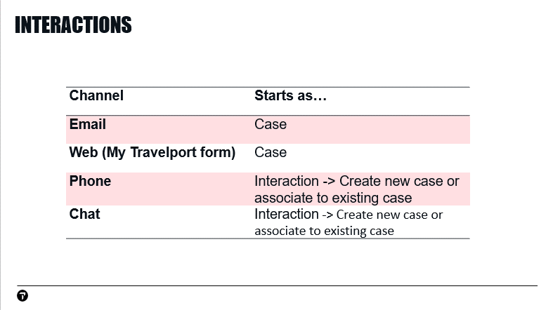

We have looked at ways customers can create cases for themselves by sending an email or filling in a form in MyTravelport. For issues reported in these ways, ServiceNow initially creates a **case**.

The way most issues are reported is by customers calling the help desk. For issues reported by phone, the help desk initially creates an **interaction**. From this interaction, the help desk can create a new case (if it’s a new issue) or assign the interaction to an existing case (if the call is related to an issue the customer has already reported).

## Interactions - eLearning

For an overview of creating interactions, let’s watch an eLearning.

***Instructor: Have students complete the ServiceNow Agent Workspace eLearning in WiLearn (Wipro) or Percipio (Internal Travelport). Time to complete eLearning: approximately 40 minutes.***

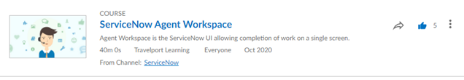

## Create an interaction - demo

|  |  |
| --- | --- |
|  | To create a new interaction, begin by selecting the **+ sign** in the top left hand corner.  It is **critical** that an interaction is created for **every** incoming phone call. |
|  | This opens a blank Interaction form, with fields for us to fill-in.  The asterisk (*) next to some field labels indicates required fields.  Because we haven’t saved the interaction yet, the **State** is **New**.  **Assigned to** is the name of the agent who created the interaction. |
|  | Notice the **SID / PCC**, **Account**, and **Contact** fields. These are the fields you will use to identify the customer and the agency they are associated with.  **Cores** is populated from the Account but can be edited by the helpdesk.  The Interaction dialog is designed to be flexible, to help when you are working with customers. You can fill-in these fields in any order.  For example, while the customer is talking to you about their issue, you can type what they are saying in the Short Description and Description fields.  Once they finish talking, you can fill-in the contact and account information.  This provides a **much** better experience for the customer than if you interrupt their flow to ask for the account information, then ask them to repeat what they were telling you about their issue. |

|  |  |
| --- | --- |
|  | For this example, assume the customer’s CIDB number is 441345. In the live system, this number would usually be populated by the phone system. For this example, we need to type in the CIDB number.  At the beginning of the number, we will type an asterisk character. This is a shortcut so we don’t have to type the zeros at the beginning of the account number.  **In Account,** type**: *441345**  From the similar values list, select **Galileo International**. This is an internal account number we can use when want to avoid creating cases for live customer accounts. |
|  | SID/PCC is short for Subscriber ID / Pseudo City Code.  An account can be linked to one primary SID/PCC and multiple secondary SID/PCC’s.  Usually, customers know their SID / PCC and can tell you what to enter in this field.  For this example, let’s assume the customer doesn’t know their SID / PCC and we need to look this up in ServiceNow. |
|  | Notice the letter “i” in a circle on the right side of the Account field.  Anytime you see this icon, you can click it to open the field in a new tab. In this example, we can click the “i” to open the account.  Clickthe **i**. |
|  | The Account opens in a new tab. Notice we have tabs that let us view the account’s SID / PCC’s, contact linked to the account, and cases for this account.  Selectthe **SIDs/PCCs** tab. |
|  | We can select the text of the SID / PCC, then copy it.  Copythe **SID/PCC.** |
|  | To return to the Interaction we are filling-in, we need to select the Details tab.  Selectthe **Details** tab**.** |
|  | Pastethe **SID / PCC.** |

### Select a contact for the case

|  |  |
| --- | --- |
|  | Next, we want to select the contact for our case. We will first search for the contacts that are already linked to the CIDB, to see if the customer is already in the system.  When you are searching for the contact, it is a best practice to click the magnifying glass rather than clicking in the field.  If you click in the Contact field, it shows contacts that have been selected recently. These contacts may or may not be linked to the account you selected, such as if you were previously working on a case for a different account.  Clickin the **Contact** field to show the recent selections. |
|  | If you search for the contact by clicking the magnifying glass, it only shows contacts that are linked to the selected account.  Selectthemagnifying glass for **Contact.** |
|  | A pop-up displays with contacts linked to this account.  If the customer was in the system and linked to this CIDB, we could select them here.  Selectone of the contacts**.** |
|  | We have now filled-in the required fields for SID / PCC, Account, and Contact.  These three fields were already in ServiceNow and all we needed to do was search for and select them.  Most of the time, this is all you need to do to fill-in these fields.  You will never need to update the SID / PCC or Account in ServiceNow. Occasionally, you may need to update contacts.  Next we will look at situations where this is required. |

## Create a Contact – Demo

**Instructor**: if using the ServiceNow production site for this demo, please do not actually create a contact.

|  |  |
| --- | --- |
|  | **Instructor: clear the contact. Enter a contact that does not exist for this account.**  Sometimes, the customer you are speaking with is not found in the ServiceNow database.  This can happen if they are a new hire at their agency or have never called the help desk before.  When this occurs, we need to create their contact in ServiceNow. |
|  | For this example, let’s assume our customer is not found in the contacts linked to this CIDB, so we need to create their contact record.  To create a contact for this case, **select** the **Create Contact in MyTravelport** button in the top right hand corner**.** |
|  | The MyTravelport credentials dialog displays.  **Enter** the credentials for your internal MyTravelport account**.** |
|  | **Enter** the customer’s credentials.  **Instructor:** If you are using the ServiceNow production site (<https://travelportprod.service-now.com>) for this demo, **STOP HERE**. Do **NOT** create a bogus contact on production. Have students refer to the steps in the student workbook for the rest of this process.  If using the ServiceNow test site (<https://travelporttest.service-now.com>), it’s fine to create a contact and have students create contacts.  **Click Create Account.** |
|  | A message confirms the contact is created.  **Click Close.** |
|  | We are returned to the Interaction.  Now that we have created our contact, we need to apply them to our interaction.  Let’s begin by searching for the contact we created.  **Select** the magnifying glass for the **Contact** field**.** |
|  | A Contact pop-up opens with a list of contacts who are linked the account.  **Select** the contact we just created. |
|  | The contact we created is now the contact for our interaction. |

If your customer doesn’t already have a contact in ServiceNow, it is a best practice to create the contact from ServiceNow using the process we just looked at.

It is also possible to create a contact from the MyTravelport portal. This is much slower than creating them in ServiceNow, so it is not recommended to do it this way.

In this example, the contact did not exist in ServiceNow at all. Sometimes, the contact is in ServiceNow, but they are not linked to the Account you have selected for the interaction. We will see how to handle this situation next.

## Link a contact to a CIDB – SLIDE 10

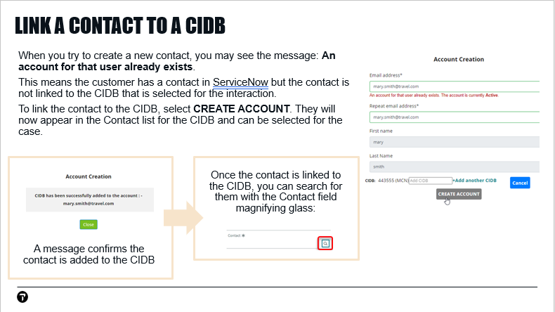

In the example we just looked at, we needed to create a new contact. Sometimes, when you try to do that, you will see the message: **An account for that user already exists**

This message means the contact exists, but they are not linked to the account you selected for your interaction.

## Link a Contact to a CIDB – DEMO

|  |  |
| --- | --- |
|  | **Instructor: clear** **the contact. Enter a contact that exists in ServiceNow but is not linked to the CIDB you have selected.**  As we saw in the previous example, the contact is not found. |
|  | We will try to add the contact.  Select **Create Contact in MyTravelport.** |
|  | Enter your MyTravelport credentials. |
|  | We receive the message that the contact already exists.  Select **Create Account.** |
|  | A message confirms the contact is now linked to the CIDB for the interaction.  Select **Close.** |

## Interaction - more fields - Demo

Now that we have assigned a contact to our interaction, let’s finish filling-in the remaining fields.

|  |  |
| --- | --- |
|  | As you saw in the eLearning, the icons in the right toolbar allow you to do the following:   * Search for knowledge articles (graduation hat) * Add an attachment (paper clip). Attachments to interactions are **not** visible to customers. * Apply a template (white page) * Launch ScreenMeet. ScreenMeet is the application the Help Desk uses to view the customer’s screen. |
|  | When you fill-in the Short description with the customer’s issue, ServiceNow displays knowledge articles related to that issue in the right toolbar.  For example, let’s assume a customer calls with a question about how to display seat maps.  In the **Short description** field, enter**: display seat map** |
|  | A knowledge article related to Seat Maps displays in the right toolbar, to help us assist the customer with their question or issue related to this topic. |
|  | Now that we have filled-in the required fields for the interaction, we are ready to save it.  **Select the Save button in the top right hand corner.** |

Before we move on to cases, let’s do a review of interactions.

## Review: Interactions - Slide 11

Instructor: correct answers:

1. interaction
2. b

## Saved interaction

|  |  |
| --- | --- |
|  | Once we save the interaction, the State changes to **Work in Progress**. |
|  | Notice we have 2 new options in the top right hand corner:  **Create Case** – creates a new case from the interaction  **Associate Record** – Associates the interaction to an existing case, such as if a customer is calling for an update on an issue they submitted previously. |

# Cases

## Interactions and Cases - SLIDE 12

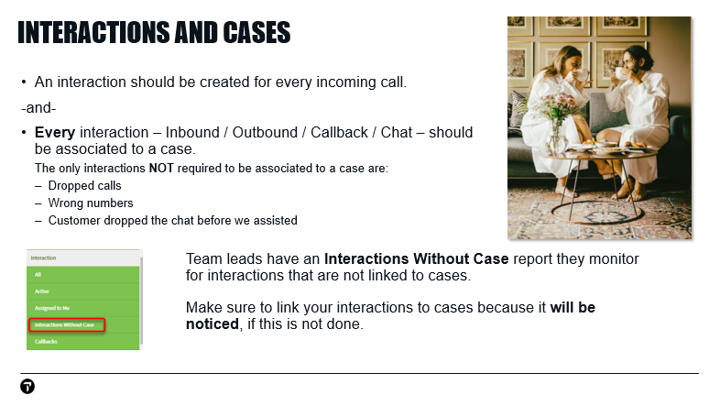

## Associate interaction to existing case

|  |  |
| --- | --- |
|  | For this example, let’s assume the customer is calling for an update on a case they previously submitted.  Since there is already a case for this issue, we want to locate that case and associate our interaction to it.  Update **Short description** to **Status check.** |
|  | In the top right hand corner,select the **Associate Record** button**.** |
|  | The **Create New Interaction Related Record** dialog opens for us to select the case we want to link to our interaction.  Under **Record Type**, verify that **Case** is selected as the option we want our interaction to link to.  Notice there are some other options in the Record Type drop-down that we could link our interaction to, if appropriate. |
|  | If the customer knows the case number they are calling about, we can enter it in the Task field. |
|  | If the customer does **not** know their case number, we can view a list of cases they have submitted, to locate the case for them.  To view cases a contact has submitted, select **Lists > Contacts > filter by contact > Cases** tab. |
|  | If the customer is following-up on a case submitted by someone else at their agency, we can also view cases for the account.  To view cases submitted for a CIDB,select **Lists > Accounts > filter by CIDB > Cases** tab. |
|  | Once we find the case we are looking for, we can copy the case number. |
|  | Select the **Create New Interaction Related Record** tab**.** |
|  | Paste the case number. |
|  | In the top right corner, select **Save.** |
|  | A message confirms we have linked our interaction to a case. |
|  | Since we have linked the interaction and are done working on it, we can now close the interaction tab.  Click the **X** for the interaction tab. |

## Create a new case from an interaction

In the previous example, we linked our interaction to an existing case. Next, we will create a new case from the interaction.

|  |  |
| --- | --- |
|  | Let’s create a new interaction.  Click the **+** tab. |
|  | Fill-inthe required fields and save the interaction. |
|  | For this example, assume the customer is calling about a new issue. Because this is is a new issue, we need to create a new case.  Select the **Create Case** button. |
|  | The case is created in a new tab.  A case number, beginning with the letters **CS**, is automatically assigned by ServiceNow.  Notice the SID/PCC, Account, and Contact are filled-in from the interaction. |
|  | The case status is **New** because we haven’t saved the case yet. |
|  | Case Source is the sources where cases can originate. Phone is selected by default. |
|  | **Opened** is filled-in by ServiceNow with the exact time when we created the case. The text in this field is grey, so it can’t be changed.  **SLI** stands for **Service Level Indicator**. It is usually a number from zero to 4, with a lower number receiving faster handling. ServiceNow assigns the case SLI from the account SLI.  These fields are in grey text, so we cannot edit them. |
|  | Record Locator is a mandatory field.  In the **Record Locator** field, enter**: test** |
|  | To select the vendor using predictive search, enter the vendor type followed by the vendor code, for example:  AIR DL CAR ZI  If you don’t know the vendor code, you can use the magnifying glass to search for them.  Select a vendor. |
|  | Cores is populated from the Account but can be edited by the helpdesk.  Add a core. |
|  | We can also remove a core by selecting the X.  Remove a core. |
|  | Enter a Problem Type and Product that best describes the customer’s issue.  Select **Problem Type: Discrepancy**  Select **Product: Smartpoint.** |
|  | Once we specify Problem Type and Product, required fields for Category and Subcategory display.  These fields are the categorization for the ticket.  The list of categories on these drop-downs is very long. If you fill-in the categories by selecting options from the drop-down, it can be slow and use valuable time that would be better spent investigating the customer’s issue.  To fill-in these fields quickly and consistently, it is recommended that agents use a template to complete categories and other case fields, when possible. |

### Use templates to fill-in case fields - Demo

|  |  |
| --- | --- |
|  | To access templates, select the white page icon in the right toolbar. |
|  | A list of templates displays on the right side of the dialog.  You can toggle this list on and off by selecting the white page icon.    Your supervisor may have provided your team with additional templates, so you may have a different list of templates than the one I have. |
|  | If you have a very long list, notice you can enter search text to filter the list.  Search for the **fares** template. |
|  | Scroll down the **case > Details** tab to show blank fields.  Notice we still have a lot of blank fields in our case workspace. As soon as we select our template, many of those will be filled-in for us.  It is a best practice for agents to use templates as much as possible because they will give you a faster handling time and ensure the various fields are filled in correctly for the type of case you are working. |
|  | For this example, let’s assume we have helped the customer with an issue related to fares, so we can use the Fares and Pricing template.  Watch how the categories and other case fields are filled in as soon as I select the Fares and Pricing template.  Select the **Fares and Pricing** template. |
|  | A message appears at the top of the case workspace to confirm the template was applied.  The message also tells us which fields were filled in for us by the template.  This is a time saver because we don’t need to manually fill-in these fields. |
|  | Below the white page icon, notice the black page icon. This icon is for **quick templates** (also known as **response templates**). Quick templates are reusable messages that you can copy and paste into a comment or email. Managers are able to create quick templates. |

### Case workspace fields - continued

We will look at more best practices for using templates in a few minutes. For now, let’s look at the other fields in the case workspace.

|  |  |
| --- | --- |
|  | If applicable, select priority process ADMP/INV01/XADM  ADMP - issue has ADM potential; X - no ADM potential  INV01 - if ticket has been escalated. This option is applied automatically by ServiceNow. It cannot be applied by the Help Desk. |
|  | The case **Severity** is populated by ServiceNow, but can be changed by the agent. |
|  | Problem – Known issues with software are sometimes identified as problems. If applicable, the problem identifier will appear here. |
|  | **Parent** - If this was a child case, we would see the major case number in this field. We can also assign this case to a major case by entering the major case number here. You will learn more about major cases later in this training. |
|  | **Billable** defaults to yes, no, or blank based on categorization. Where blank is the default, the helpdesk agent will need to select a value. |
|  | In the Billable drop-down, notice the **ESD** option.  This stands for Extended Services Desk and is billable at a different rate. |
|  | If the agent is assigned to only one group, **Group Opened By** will default to their group.  If the agent is assigned to multiple groups, they have to specify the Group Opened By.  Once the case is saved, this field disappears from the workspace. |
|  | **Assignment group** is the group the case is initially assigned to. It defaults to the Group Opened By, but can be changed by the agent.  If you are escalating the case to another group, this is where you would enter the other group. |
|  | **Assigned To** defaults to the agent who is creating the case.  If I re-assign the case to another group that I’m not a member of, this field clears. |
|  | In the case form, **Short description** is visible to the customer, so be mindful of entering description text that will be helpful and appropriate for them.  You may recall, we also entered Short description in the interaction. Fields entered in interactions are **not** visible to the customer.  ServiceNow also uses the text you enter in short description to find knowledge articles related to your ticket.  In **Short description**, enter**: Claim PNR error** |

### Knowledge Results

|  |  |
| --- | --- |
|  | Knowledge articles related to your short description text appear in the contextual area on the right side of the display.  If you attach a knowledge article to your case, please be sure the content is appropriate.  For example, if you are assisting an external customer, verify the content does not have the word “Internal” in the article link.  Click a knowledge article to view it. |
|  | In the bottom toolbar, lower right-hand corner, notice the left and right arrows.  Use these arrows to scroll through the knowledge articles ServiceNow provided, based on your case’s Short Description text. |
|  | Notice the links at the top of the article:  **Attach** lets you attach a knowledge article to your response to the customer. It is a best practice that Help Desk agents use this method to direct customers to knowledge articles. We will take a closer look at this option shortly.  **Helpful** marks an article as useful. |
|  | The 3-dots menu (to the right of the Helpful link) provides additional options for working with knowledge.  To notify the Knowledge team about articles that need updated, select **Flag Article** and type a comment.  To view the article in a full-page tab, select **View Full Article**. |
|  | Description field is optional, but can be used in reports. Your team lead will tell you if your group uses this field. |

## Watch List

|  |  |
| --- | --- |
|  | Just above the Notes area, we have the **Watch List** option.  The watch list option is like the cc field in an email. Anytime ServiceNow sends the customer email for the case, people in the watch list will be copied on the email. |
|  | To add someone to the watch list, enter their email in this field.  Enter your email in the watch list. |
|  | There is also a watch list option for **Accounts.**  If someone is on the watch list for an **Account**, they will be copied anytime ServiceNow sends an email to any contacts linked to that account. |

**Instructor: Scroll down to Notes / Additional Info / Closure Info**

## Notes area

|  |  |
| --- | --- |
|  | Scroll down to the Notes area. The Notes area is where we find the threads for the case.  Text in **Additional comments** fields is visible to the customer. When you add a comment and save the case, ServiceNow automatically sends an email to notify the customer their case has been updated.  **Work notes** are visible to internal only and are not seen by the customer.   * If you are escalating the ticket to another desk, this is where you would provide the troubleshooting information you have gathered from the customer so the other desk can continue the investigation. * If you are solving the case yourself, you should enter details in the work note about how you fixed the problem.   Because issues reported by customers tend to recur, the details you provide in work notes will help yourself and your colleagues when a similar problem is reported in the future.  Fill-inthe **Additional comments** and **work notes** fields**.** |

## Review: Templates, case fields - SLIDE 13

Let’s do a short review before we look at more fields in the case.

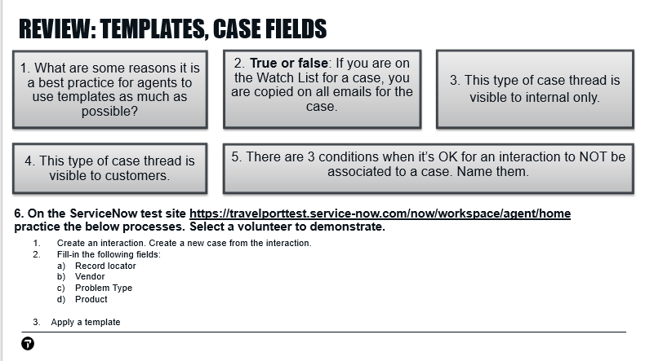

**Instructor: Correct Answers:**

1. Faster call handling time, ensure case fields filled in correctly for the type of issue
2. True
3. Work notes
4. Additional comments
5. 1. Dropped call, 2. Wrong number, 3. Customer dropped the chat before we assisted

## Creating a case – continued - DEMO

Let’s return to our case in ServiceNow.

|  |  |
| --- | --- |
|  | Scroll down to the **Additional Info** area of the case. |
| Here is additional information for the case. Most of these fields are filled-in by ServiceNow and are not updated by agents. Let’s do a quick overview of these fields.   * SDM # – Service Desk Manager (SDM) was a help desk case system previously used by certain help desk teams at Travelport. This field is no longer used, but you may find it filled-in for older cases. * SDM PR# – Problem number from SDM. This field is no longer used, but you may find it filled-in for older cases. * ESP ID – is a number assigned cases that are worked by an ESP Hardware Maintenance Vendor group * Channel - Where the case originated, such as phone or email. * Customer/External Reference – This field is used by Operators. * Send Status Emails – Whether status emails are sent for the ticket. If the customer does not want to receive status emails for a case, remove the check. This doesn’t happen very often – most people want status emails. * Opened – Timestamp when the case was created * Opened by – The agent who created the case * Generated From – For web submit cases, the title of the form the case was created from appears here * Original Group Name – Once the case is saved, the Group Opened By appears here. | |

## Propose Solution – First Call Resolution

Let’s assume we have solved the issue our customer reported and want to close this case. Once we have solved the customer’s issue, we want to set the case to **Solution Proposed** state.

Because we haven’t saved our case yet, we can close it as an **FCR** or **First Call Resolution** case. This term refers to cases that are not saved before being closed by the agent. If you save a case and then close it later, it is no longer an FCR.

|  |  |
| --- | --- |
|  | Before closing the case, make sure you type a comment explaining the solution to the customer. Customers will see this comment in MyTravelport.  If you don’t add a comment, the customer will think you closed their case without any explanation and **they** **may get very upset**.  Fill-in the **Additional comments** field. |
|  | Let’s Propose Solution on our case.  Click **Propose Solution** in the top right-hand corner of the case workspace. |

### Points to note about Solution Proposed cases

|  |  |
| --- | --- |
|  | In the Status field, we can see the case status has changed to solution proposed.  When a case is placed in Solution Proposed status, the customer is sent a status email. They have 10 days to re-open the case or it will permanently close.  If the customer re-opens the case, it’s assigned to the group and agent that proposed solution.   * If a re-opened case was solution proposed by a first level desk, it will assign to the first level agent who proposed solution on it. * If a re-opened case was escalated to a second level help desk and second level proposed solution, it would assign to the second level agent who proposed solution.   Basically, if you proposed solution on a case, you are the one the case will assign to if the customer re-opens it. |
|  | Notice the Open Case button that appears in the top right hand corner once we have proposed solution on a case.  You would select this button if you need to change the case back to Open status, such as if the customer calls back and asks that the case be re-opened. |
| If we scroll down in the Solution Proposed case, notice tabs have now appeared. These tabs appear in the case workspace once the case is saved or solution proposed. We will learn about all these tabs shortly. | |
|  | Select the **Emails** tab. |
|  | On the Emails tab, we see the emails ServiceNow has sent for this case.  Select anemail to view details. |
|  | Here is an email that ServiceNow sent to the customer.  We can use the links in this email to view the case in the customer portal exactly as the customer would see it.  Let’s select the **click here** link in the email. |
|  | This is exactly what the customer sees if they view the case in the customer portal.  The additional comments we added to the case appear here.  **ALWAYS** add a comment when you propose solution on a case so the customer doesn’t think you closed their case without an explanation. |
|  | The customer can select Accept Solution to permanently close the case or Reject Solution to re-open it.  If they don’t do anything, the case will permanently close in 10 days. This is usually what happens. |

## Attach a Knowledge Article to a case, Related Search Results - Demo

|  |  |
| --- | --- |
|  | Let’s look at how help desk agents can attach a knowledge article to a case.  We will begin by creating a new case from an interaction. |
|  | The search field at the top of Related Search Results is intially filled-in with the Short Description text from the case. |
|  | To see more articles, you can change the search text under **Related Search Results**. The search text you type here does not change the Short Description of your case.  Searching for articles from **Related Search Results** is much faster than switching to MyTravelport and searching from there. |
|  | In Related Search Results notice the **3-dots** option appears on the tile for each article.  You can attach a knowledge article from the tile by selecting 3-dots > Attach.  This is a time-saver for articles you are familiar with. |
|  | Alternatively, you can OPEN an article to verify it contains suitable information for the customer.  Open one of the knowledge articles under Related Search Results. |
|  | In the top right corner of the article, select the **Attach** link. This link attaches the knowledge article to the case.  The customer will need to be able to login to MyTravelport to view the attached article.  If you are replying to an external customer, do not send a link to an internal knowledge article.  Select the **Attach** link. |
|  | A dialog confirms the article you are attaching.  The Additional comments field lets you provide more information to the customer.  Type a comment and click **Attach Article**. |
|  | A dialog in the case workspace confirms the article is attached. |
|  | When you attach a knowledge article to your case, ServiceNow sends the customer an email.  Let’s look at the email ServiceNow sends.  Select the **Emails** tab. |
|  | Select the **email** that was last sent. |
|  | Here is the email that ServiceNow sent the customer when we attached the knowledge article.  The link ServiceNow inserts in the email takes the customer directly to the article. |

## View attached knowledge articles from MyTravelport

It’s common that issues customers reported to the help desk recur again later. The customer may remember that they have seen the problem before, but not remember what the solution was.

If the help desk agent attached a knowledge article, when they originally worked the case, the article remains linked even after the case is closed. By reviewing the article the help desk attached, the customer can often solve their own issue, without needing to open another case.

To view a knowledge article that is attached to their case, the customer must be logged in to MyTravelport.

|  |  |
| --- | --- |
|  | From the **MyTravelport Support** Portal, select the profile link in the top right corner > **My Cases**. |
|  | Select: **My Cases** |
|  | From the list of cases, select a case that has a knowledge article attached. |
|  | We can see, the link to the attached knowledge article remains enabled.  If the customer has another question about the same issue, they can refer to the knowledge article that was attached to their previous case. |

## Templates – Additional features

Previously, we looked at applying a single pre-existing template to a case. Let’s look at some additional features of using templates.

### Resolution notes filled in by template

|  |  |
| --- | --- |
|  | If we scroll down to the **Resolution notes** field, we can see that this field is filled-in with the name of the template we applied.  When you apply a template, ServiceNow automatically fills in the Resolution notes field with the template name.  This helps agents speed up handling time, because they don’t need to fill-in the Resolution notes field and provides reporting on template usage.  Please do not make any changes to Resolution Text that is entered by templates because it is used for reporting on how templates are being used.   * If the Resolution Notes field is **blank** at the time of Propose Solution, it will autofill with the last comment added to the case. * If the Resolution Notes field is **not** **blank** at the time of Propose Solution, the system will leave the field as is and not overwrite. |
|  | From here, the agent could propose solution on this case because the templates have filled-in almost all the fields. |

### Unknown Caller template

|  |  |
| --- | --- |
|  | For this example, let’s create a new case from an interaction.  Create an interaction > create a new case |
|  | In the right toolbar, let’s selectthe **templates (white page)** icon. |
|  | Next, we will selectthe **Unknown Caller** template.  The Unknown Caller template is used when an agent does not have the customer’s account information and can’t log a case under the correct account. This can occur if they are a new account that hasn’t been added to the system yet or the customer hangs up before providing their information.  If you have this situation, please make sure to use the Unknown Caller template because it will let you save the case without a contact.  Please **DO NOT** create your own template for unknown caller.  If you copy the Unknown Caller template, or create your own template for unknown callers, the feature of not requiring a contact will not be in the new template that you copy or create. This will cause invalid contacts to be created against the CIDB. |

### Apply multiple templates

Previously, we’ve looked at applying individual templates to a case. However, it actually possible for agents to apply multiple templates to the same case.

|  |  |
| --- | --- |
|  | For this example, let’s create a new case from an interaction.  Create an interaction > create a new case |
|  | If you assist a customer with a password reset issue and their account can’t be found in ServiceNow, you can use both the Password Reset template and Unknown Caller template.  Apply **Unknown Caller** template**.** |
|  | Now, apply the **Password Reset** template. |
|  | Notice the Password Reset template has filled in Problem Type, Product, Category, and Subcategory fields for us.  This saves time we would have spend selecting values for these required fields. |

### Create a template

In addition to the templates you are provided in ServiceNow, agents can also create templates themselves.

If there is a type of issue you work frequently, it is a best practice to create a template for that issue. You can then apply the template when you have a case for that issue in the future.

|  |  |
| --- | --- |
|  | The quickest way to create a template is to start with a case that has the properties you want your template to have.  In the case workspace, notice the toolbar on the right side. To open the Templates panel, select the white page icon in the right toolbar. |
|  | To create a new template, select the + (plus) icon near the top of the Templates panel. |
|  | The Create a New Template dialog opens in a new tab. Template fields are pre-filled from the case where I started creating the new template. |
|  | Let’s give the template a name that will make it easy to find in the list of templates.  In the **Name** field, enter the template name. |
|  | Remove fields from the template by selecting the **X** to the right of the field.  Let’s remove the Contact (because we probably want to apply this template to more than one contact).  Select the **X** for the **Contact** field. |
|  | I can make changes to the values in these fields as needed.  Edit the **Short description** field. |
|  | If there is another field I want to include, I can add it from the **Choose field** drop-down at the very bottom of the new template dialog. |
|  | When finished, click **Save** to save the new template. |
|  | Since we have finished creating our template, let’s close the tab. |
|  | Let’s try applying the template we created to a new case.  Create a new interaction >Create a new case. |
|  | In the right toolbar, select the white page icon to display templates. |
|  | The template we created appears on the My Templates tab.  ServiceNow automatically places templates in A-Z order.  Select the template to apply it. |
|  | A pop-up confirms the template is applied and lists the fields the template filled-in for us.  If we wanted, we could apply another template to this same case, to fill-in any additional fields that are required.  Once you begin working cases in ServiceNow, try to notice any actions you are doing over and over. You may be able to automate these tasks with a template, so you can work more effectively. |

### Global and Wipro templates

The global quick templates and those created under the Wipro group are for the top call drivers overall. For agents supporting specific countries where they get the same call repetitively, we recommend they create their own template so we don’t create a large list of templates for all users that may not be applicable to everybody.

If you have a template recommendation for the Wipro group, please discuss with your supervisor.

### Resolution Text – best practices – SLIDE 14

Let’s switch to slides to review best practices for Resolution Notes and templates.

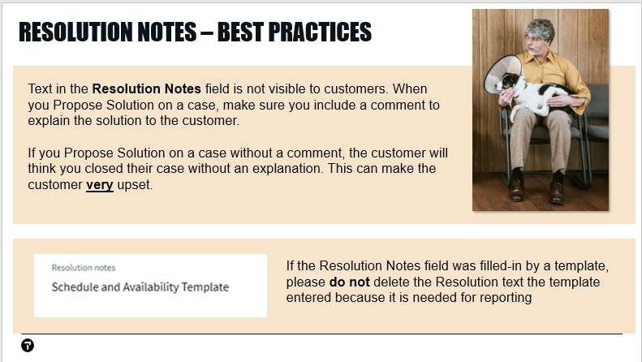

### Templates – best practices – SLIDE 15

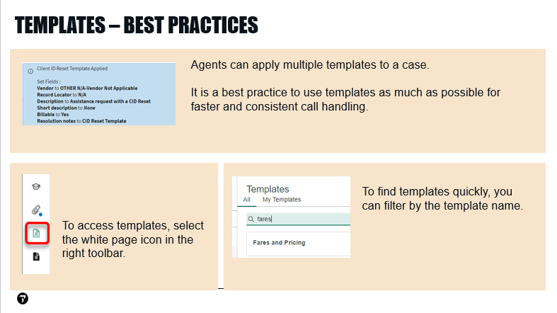

## Review: Templates, case fields continued - SLIDE 16

Instructor – Correct Answers:

1. Agents can apply **multiple** templates to a case.

2. Include a **Comment** explaining the solution to the customer. If a comment is not included, the customer will think the case was closed without any explanation being provided, which can cause them to be upset.

3. Re-opened cases assign to the agent who proposed solution on the case.

* If you propose solution on a case and the customer re-opens it, it will re-assign to you.
* If you escalated your case to another help desk and an agent at the other desk proposed solution, the re-opened case would assign to the other agent.

# More ServiceNow features

To this point, we have mainly been looking at FCR (First Call Resolution) cases that the help desk created from interactions, when a customer called the help desk.

The majority of cases in ServiceNow are FCR cases created by the help desk because of a customer phone call. So, you already know how to do the majority of your workload.

Other cases will require more or different handling, such as cases that require escalation to another help desk or cases that the customer created by sending an email or submitting a form in MyTravelport.

Let’s look at ServiceNow tools and features used with these other types of case.

## Customize the ServiceNow workspace

The ServiceNow Agent Workspace lets you customize your workspace to make your job easier and more efficient.

## Settings menu

Let’s look at the customization options available from the **Settings** menu.

|  |  |
| --- | --- |
|  | We will begin by looking at a saved case.  The **My Open** list shows cases that are assigned to me and **Open** status. |
|  | In the top right corner, select your initials > **Settings**.  The options in the **Settings** menu let you customize how cases and lists display.  Let’s take a closer look at each of these options. |
|  | **Show Ribbon** – This option shows or hides the middle ribbon. You should have this option de-selected by default, so the middle ribbon is hidden.  It’s generally recommended to keep the default of hiding the middle ribbon.  Displaying the middle ribbon takes up a lot of room on the screen and makes you spend more time scrolling to the various fields you need to fill-in. |
|  | **Show Sidebar** shows or hides the right sidebar.  This sidebar is the area where Knowledge Search results display. |
|  | To see how the **Wrap List Text** option works, we need to view a case list.  Let’s view the **My Open** cases list. |
|  | When **Wrap List Text** is selected, text in the various columns wraps to the next line. |
|  | When **Wrap List Text** is **not** selected, text in the columns is cut off. |

## Expand / Collapse Details panels

When working with a saved case, the various panels on the Details tab can be expanded or collapsed.

|  |  |
| --- | --- |
|  | Let’s view another saved case. |
|  | At the top of the tab for the saved case, we have a new field: **Spotlight Score**. This field does not appear until the case has been saved.  **Spotlight Score** is the sequence in which an incident or problem needs to be resolved based on impact and urgency. |
|  | Just above the Details tab, there is a small down arrow.  Select this down arrow to display the ribbon. |
|  | On the left side of the ribbon, we have details for the case’s contact. |
|  | A timeline for events in the case appears in the middle of the ribbon. For further details, select the **Show Details** drop-down below the timeline. |
|  | On the right side of the ribbon, the case SLA appears. The circle changes color as the SLA gets closer to breaching. It starts as green, to yellow, and finally to red, when the SLA is breached. |
|  | To collapse the ribbon, select the **up arrow** just above the **Contact** section. |
|  | When we are viewing a saved case, the **Details** tab is selected by default.  Within the Details tab, there are several panels. The **Case** panel is at the top of the list of panels.  By default, all of these panels are expanded. This can result in a lot of scrolling to find what you are looking for.  Notice the **up arrow** on the right side of the **Case** panel (next to the scrollbar.)  To collapse the **Case** panel, select the **up arrow**. |
|  | The **Case** panel is now hidden.  This saves me work because, instead of having to scroll down to the **Additional Information** panel, I can simply collapse the **Case** panel. |

## Zoom Options

While working in ServiceNow, you can also use the browser zoom in or out options to see more of the screen. There are multiple ways to do this.

|  |  |
| --- | --- |
|  | Zoom options are available from the **3 dots menu** in the top right-hand corner of the browser.  Notice the + and - to the right of the **Zoom** option.   * The - (minus) zooms the screen **outward**, so you can see more of the screen. This helps minimize scrolling if you are reviewing a large screenshot or lengthy comment a customer sent. * The + (plus) zooms the screen inward, so you see less of the screen, but more detail. You might use this option if you need to zoom in to see details in a screenshot. |
|  | The plus and minus are also available from the **magnifying glass** on the right side of the address bar, in the top right hand corner of the browser. |

## HTML / Rich text Editor

The Agent Workspace offers an HTML Editor feature so you can copy/paste images and screenshots into additional comments and work notes, bullet point, italicize, etc.

|  |  |
| --- | --- |
|  | To access the **Rich Text Editor**, we need to view a case that has been saved. |

|  |  |
| --- | --- |
|  | Once a case is saved, the **Toggle compose settings** option appears in the **Compose** area (where we enter comments and work notes).  This option does not appear until the case has been saved. |
|  | Under **Toggle compose settings**, select the slider to enable **Rich text editor**.  When the **Rich text editor** option is enabled, comments and work notes display options for bold text, bullets, etc.  You can also paste screenshots into comments and work notes.  Once enabled, **Rich text editor** remains available for additional comments and work notes. |

## Customize the Agent Workspace: SLIDE 17

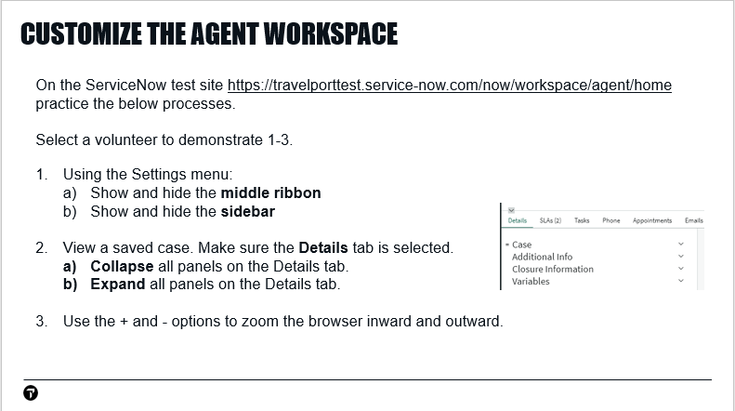

## Claim Cases: Locate Unassigned Cases: SLIDE 18

Assigned groups are responsible for assigning cases to an individual on the team, or claiming cases from their queues.

* To view cases for your group(s) that are not yet assigned to an agent, select **Lists > Unassigned for my groups**.
* To assign cases from the list select the case checkbox > Edit > update Assigned to field. (The checkbox appears when you hover your mouse on the case in the list.)

## Locate Unassigned Cases – DEMO

Let’s look at finding cases that are not assigned to an agent.

|  |  |
| --- | --- |
|  | Select the **Lists** tab > **Cases** > **Unassigned for my group** list.  If you are ready for another case to work, this list can help you find it.  Your team may have additional cases lists that you work from, but **Unassigned for my group** is the default. |
|  | We can confirm these cases are unassigned by checking the **Assigned to** field. If a case is assigned to a help desk agent, the agent’s name will appear in this field.  If we scroll to the right side of the list and look at the Assigned to field, we can see it is empty. |

## Assign the case

|  |  |
| --- | --- |
|  | To assign a case from the list, **select** the checkbox on the left side of the case number.  You can select the checkbox for one case or multiple cases. |
|  | In the top right hand corner, **select** the **Edit** button.  The number on the button is the number of cases you are editing. |
|  | **Edit item** appears in the contextual area on the right side of the display.  Scroll downto **Assigned to** and type the name you want to assign to.  Select the agent from the similar names list. |
|  | In the lower right hand corner, **select Update** to save the changes.  Depending on your profile permissions, you also may be able to use this process to assign cases to other agents. |

## Assign case in case workspace

You can also assign a case to yourself within the case workspace. There are a few ways to do this.

|  |  |
| --- | --- |
|  | In the **Unassigned for my group** list, clicka case number, to open the case workspace. |
|  | **Type** your name in **Assigned to**, then select your name from the predictive search list. |

## Web cases

|  |  |
| --- | --- |
|  | While we are on the subject of assigning cases, let’s look at a web case, because they are a little bit different.  Web cases are created when customers and internal users submit the forms in MyTravelport.  To view Web cases, select **Channel** column > 3-dots > filter on **Web**  To apply the filter, select Apply. |
|  | **Select** the number of the case you want to open. Let’s select a case that is **New** status. |
|  | When you first open the web case, it might look like the customer hasn’t provided any information.  To see the information from the form, selectthe **Details** tab and scroll down to the **Variables** section at the bottom.  Here, we can see the various fields in the form and the customer’s entries in the field. |
|  | If the customer provided an attachment, the paperclip in the right toolbar will display a small blue dot. |
|  | When an attachment is added to a case, ServiceNow automatically adds a comment with the name of the attachment and the time it was added. ServiceNow does this for comments added by the customer as well as the help desk agent.  You can view these comments in the case > Activity stream.  These comments make it easy to see:   * The sequence that attachments were added * Who added the attachment (agent or customer) |
|  | **Complete** the required fields, assign the case to yourself. |
|  | Save the case. |
|  | Notice that the case is still **New** status, even though we have saved it as assigned to an agent.  We are also missing the buttons we would usually have for saved cases, such as Request Info and Pending Internal.  For websubmit cases, we need to select the **Accept** button to enable these options. |
|  | Once Accept is selected, the status changes to **Open**.  We also have the pending status buttons. |

## Special Handling Notes

When you assign a CIDB to an interaction or case, you will sometimes see a Special Handling Note pop-up. Special Handling Notes provide details about the account to help with working the case.

Let’s switch to the slides to look at an example Special Handling Note

### Special Handling Notes – slide 19

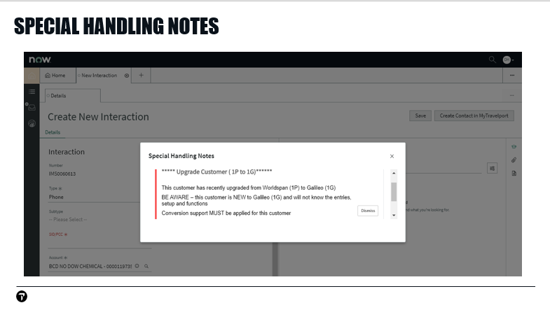

Here is an example of a Special Handling Note. In this example, ServiceNow displayed the pop-up message when the agent assigned CIDB 119735 to the Interaction.

The Special Handling Note in this example tells us the account is upgrading to Travelport+. This note lets us know that the account requires conversion support, because they won’t know the various entries and functions.

If you see a Special Handling Note pop-up, be sure to read it carefully and follow the instructions because it will help you work the case correctly.

If you Dismiss a Special Handling Note, it will continue to display. This is working-as-designed, to make sure agents action the instructions in the notes.

# Search and Filter

|  |  |
| --- | --- |
|  | Let’s look at the list of cases in ALL statuses. This list includes cases in both open and closed statuses.  Under Lists > Cases, select **All.** |
|  | This time, we will use the 3 dots menu in the list column headers to search.  When we selectthe **Number** column > **3 dots** menu, we can see the Filter defaults to the **contains** option.  This will find our search criteria if it appears anywhere in the case number. |
|  | If we selectthe **Filter** drop-down, we have several options for how we want our search performed.  These options are a little different for each column. |
|  | For this example, we want to selectthe default option (**contains**). |
|  | Fill-inthe case number and click **Apply**. |
|  | Here is the case we are looking for. |
|  | Let’s try another search for accounts with the word **travel** anywhere in the name.  In the **Account** column, selectthe **3-dots** menu.  Filterfor account names that contain the word **travel.**  To run the search, click **Apply**. |
|  | The list of filters in the contextual area shows why our search didn’t work.  Our previous search for a case number combined with the next search we did for account name containing **travel**. |
|  | If you have the contextual area minimized, you can see the searches were combined because the filter icon in the top right hand corner shows 2 filters. |
|  | To clear our previous search, select the **X** for the search we did for case number. |
|  | After removing the case number filter, selectthe **Refresh List** icon in the top right hand corner. |
|  | The resulting list is accounts that have the word t**ravel** anywhere in their name. |
|  | If you want to start a new search in the current list, you can quickly remove all conditions by clicking the **Restore Defaults** button at the bottom of the Filter contextual area.  This removes previous search filters so you can start a new search. |

Next, we will look at how to search and filter in ServiceNow. We have covered some of this already, but this time we will look at the process in more detail.

### Global Search - DEMO

If you know the case number you are looking for, Global search is the quickest way to locate the case.

|  |  |
| --- | --- |
|  | To expand the Global Search, clickthe magnifying glass in the banner.  In the Global Search field, typethe case number to search for.  From the predictive search list, selectthe case. |
|  | Global Search also lets you type the case number without CS at the beginning, or type only part of the case number.  However, if you do it this way, the search results can be confusing because a number you typed might be a case number and also an account number or phone number. |

## Filter out / Show matching

Another option that is useful is the ability to filter out certain values in a list.

|  |  |
| --- | --- |
|  | To return to the list of All cases, select **Lists > Cases > All.** |
|  | If I’m looking at a list of cases and I don’t want to see cases for a certain country, I can filter out the country I don’t want to see.  To filter out cases for a country, begin by locatinga case that has the country to filter out.  Hoveron the country to filter out, then select the 3-dots menu. |
|  | From the **3 dots** menu, select **Filter Out**.  This hides cases that have the country so they do not appear in the list. |
|  | If I review the filters contextual area, I can see this filter hides cases that have the country I selected as well as cases that don’t have a country code. |
|  | **Show matching** is the opposite of Filter out because it hides everything except for the option you select.  For example, if I want to see only cases that are New status, I would locatea case in **New** status>select **3-dots** menu **> Show Matching** |
|  | The Filter contextual area shows Status added to the list of filters applied to the list.  This example shows how you can apply multiple filters to drill-down to exactly the cases you are looking for. |
|  | Customers can also use Filter Out and Matching to organize their cases in MyTravelport.  Let’s switch to MyTravelport and view **My Cases**. | |
|  | To display the Filter Out / Matching options, right-click a field in My Cases. | |

## Review: Search and Filter – SLIDE 20

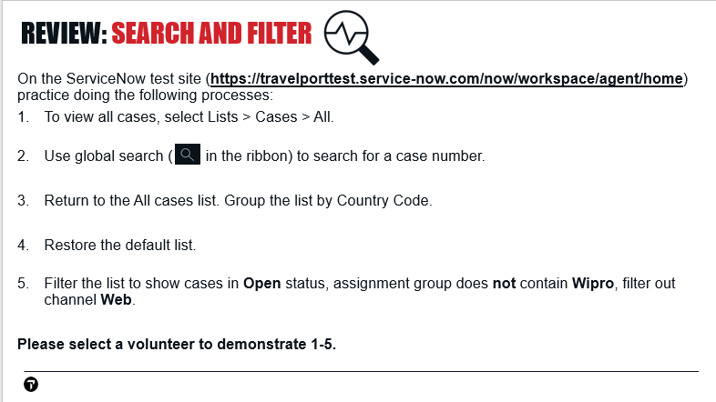

# Categorization

Up to now, we have been using templates to fill-in the Category, Sub-category, and Problem fields. This is the best practice, because templates help you fill-in these fields quickly and consistently.

However, there will also be times when you need to complete these fields manually.

## Categorization – SLIDE 21

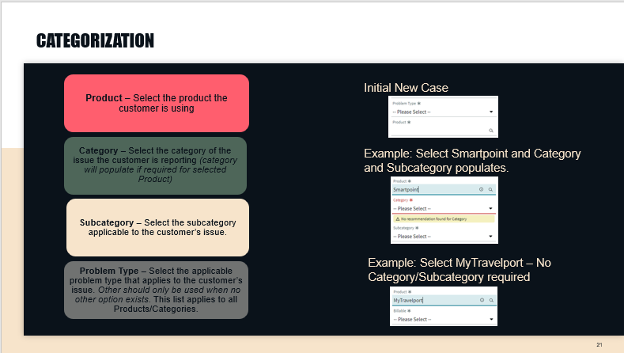

This slide shows an overview of the process you would follow to complete the Product, Category, Subcategory, and Problem Type fields without a template.

* In the **Product field**, select the product the customer is using.
* For **Category**, select the category of the issue the customer is reporting. Depending on the Product you selected, Category may fill-in automatically or may not be required.
* For **Subcategory**, select the option that is applicable to the customer’s issue.
* To fill-in **Problem Type**, select the option that applies to the customer’s issue. Other should **only** be used when no other option is appropriate.

Depending on the Product you select, the Category and Subcategory field may not display. As you see in the slide, if Smartpoint is selected as the Product, it is required to fill-in the Category and Subcategory.

However, if MyTravelport is selected as the Product, the Category and Subcategory fields do not display and, thus, are not required to be filled-in.

## Top Call Drivers to Categories – SLIDE 22

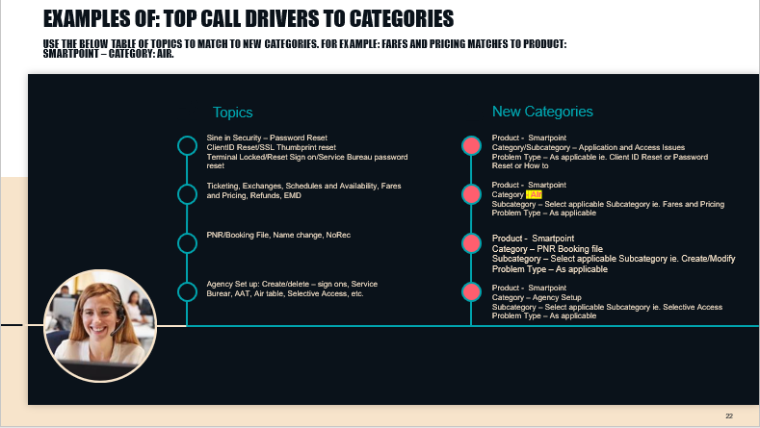

This table in this slide shows the topics where customers most often report issues and the categories you should select for these topics in ServiceNow.

For example, if the customer is reporting an issue related to Fares and Pricing, you would select:

* Product – Smartpoint
* Category – Air
* Subcategory - Fares and Pricing
* Problem type – *select as appropriate for the customer’s issue*

## Categorization – DEMO

Let’s look at manually filling-in categorization. For this example, assume the customer is reporting an error in a Smartpoint Fares display.

|  |  |
| --- | --- |
|  | Create a new interaction > create a new case. |
|  | For **Problem Type** select: **Error Response** |
|  | For **Product**, begin typing **Smartpoint**.  From the similar names list, select: **Smartpoint** |
|  | When I select Smartpoint as the Product, notice the Category and Subcategory fields appear for me to fill-in. |
|  | When I refer to the table in the slide, I can see that I should select:   * Category – Air * Subcategory – Fares and pricing |
|  | From the **Category** drop-down, select**: Air**. |
|  | Notice the options that appear in the **Subcategory** drop-down. These are different, depending on which Category you selected.  From the Subcategory drop-down, select**: Fares and Pricing** |
|  | Now that I have my Product, Category, and Subcategory, I can proceed with filling-in the remaining fields of my case. |
|  | I’m going to reload the page, so we can see how the selection we make for **Product** affects the **Category** and Subcategory fields. |
|  | The case workspace is refreshed.  The **Category** and **Subcategory** fields are hidden again. |
|  | For this example, assume I have a call from another customer who is having an issue with MyTravelport.  In the Product field, start typing **MyTravelport**.  When the similar names list displays, select **MyTravelport**. |
|  | Because MyTravelport does not require a Category or Subcategory, these fields remain hidden. |

# Chat

ServiceNow makes it easy to chat with our customers.

## Chat with a Customer - DEMO

**Instructor: In another browser, impersonate customer who has access to chat. Make sure their chats go to a queue that you have access to.**

|  |  |
| --- | --- |
|  | In the left toolbar, selectthe **Inbox** icon and set your status to **Available**.  We have to do this so the system can recognize that we’re available to accept chat conversations. |
|  | Notice the additional statuses.  You might select **Busy** if you are working on something else or **Away** if you are going on your lunch break.   When you select these other statuses, don’t forget to set your status back to **Available**, so you can receive chats. |
|  | Open another browser.  To show the chat process, I need to impersonate an end user customer in a different browser. |
|  | The end-user selects **Chat** to start the process |
|  | I’m returningto the browser where I have ServiceNow open.  A notification for the customer’s chat has appeared in a pop-up.  To accept the customer’s chat, select **Accept**. |
| The customer chat appears on the left side of the display.  On the right side, we can see ServiceNow has automatically created a new interaction for this chat and that the customer’s details are filled-in for us. | |
|  | At the bottom of the chat, notice the options:  **Paperclip** – add an attachment  **Arrow** – Transfer the chat to another queue  **Person** – Transfer the chat to another agent |
|  | In the top right-hand corner, notice we have more options for working with the chat.  **End Chat**: Ends the chat  **Save**: Saves the interaction  **Create Contact in MyTravelport**: Works as we saw earlier to create a MyTravelport contact.  **Create Case**: Creates a new case for the interaction similar to the process we looked at earlier. |
|  | Under the 3 dots menu, there is an option to associate the interaction to an existing case. You might use this option if the customer is contacting us to ask for an update on an issue they reported previously. |
|  | Selectthe **Create Case** option.  It is a best practice to begin filling in the case while the chat with the customer is in-progress, such as while you are waiting for the customer to type a reply.  Don’t forget: it’s **required** that interactions are associated to cases. |
| The case displays next to the chat dialog.  ServiceNow has updated contact fields for you. We can complete the other mandatory fields in the case workspace as the customer provides their details, using the process we looked at earlier. | |
|  | Let’s assume we have solved the customer’s issue and are ready to end the chat session.  If we are in the case, we need to selectthe **Details** tab to switch back to the interaction. |
|  | Let’s end the chat.  In the top right hand corner, selectthe **End Chat** button. |
|  | Let’s switch back to the Case so we can finish filling-in the customer’s details.  Selectthe **New Case** tab. |
|  | Don’t forget to add commentsexplaining the resolution of their issue to the customer.  Fill-in the **Additional comments** field. |
|  | When all mandatory fields and resolution text are completed, select **Propose Solution**. |
|  | ServiceNow saves chat transcripts in the Interaction.  If the transcript is very long, ServiceNow saves it as an attachment. |

### What happens if a chat isn’t answered?

It’s **critical** that chats are accepted promptly. If a chat isn’t accepted quickly, the customer will be stuck in the queue and is likely to become upset.

Let’s look at how we can setup notifications, so we don’t miss incoming chats.

|  |  |
| --- | --- |
|  | Switch to the other browser.  Let’s see what happens if a chat isn’t answered.  I’ve switched to the other browser where I’m impersonating an end-user.  The end user selects **Chat** to start the chat process |
|  | Switch to ServiceNow.  If I’m in ServiceNow, I see the notification to accept the chat. This time, I won’t pick it up.  In another browser tab, launch MyTravelport.  But, if I’m working in another application, such as Smartpoint or MyTravelport, I don’t see the pop-up that tells me I have an incoming chat. |
|  | Let’s switchbackto the customer’s browser again.  Here is the message the customer sees while they are waiting for an agent to accept their chat.  If they see this message for a long time without anyone picking up the chat, they are likely to become upset. |

## Chat Notifications

To ensure we don’t miss any chats, we can setup notifications.

|  |  |
| --- | --- |
|  | In the left toolbar, selectthe **Inbox** icon.  Selectthe **gear** icon. |
|  | It’s **CRITICAL** to enable the first two options **Inbox Desktop Notifications** and **Inbox Audio Alerts**.  When a new chat is received, these settings will display a pop-up in the lower right hand corner of your screen and play a sound.  This pop-up will appear even if you are in a different application. |
|  | The settings **Conversation Desktop Notification** and **Conversation Audio Alerts** display a pop-up and play a sound when a customer responds to a chat you have already accepted.  It’s recommended to also enable these notifications. |
|  | I’m minimizing ServiceNow, so we can see the desktop notification that will now appear when a chat is received. |
|  | I’m switching to the browser where I’m impersonating the customer and starting a new chat. |
|  | The desktop notification now displays in the lower right hand corner of the screen.  We have this notification even if we are not viewing ServiceNow. |

## Review: Chat - SLIDE 23

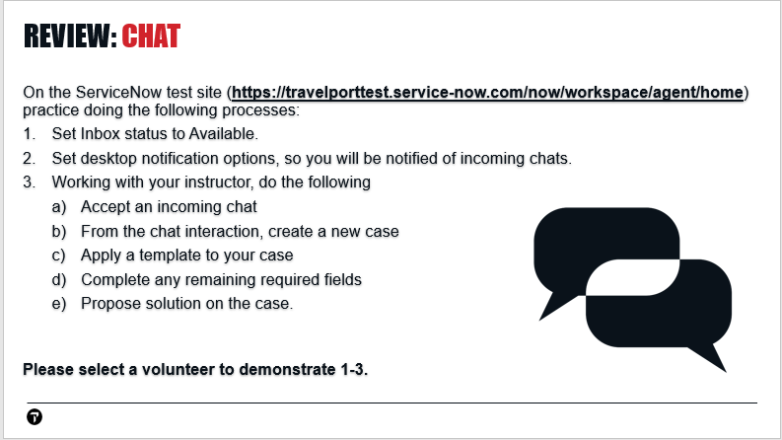

### Notification Preferences – DEMO

We are now going to look at additional notifications available to you in ServiceNow.

You can select notifications you want to receive for many events in ServiceNow, such as when a case is updated or assigned to your group.

|  |  |
| --- | --- |
|  | To setup notifications, I need to switch to the **Platform UI** tab in ServiceNow. |
|  | Select the **gear** icon in the top right hand corner.  Email notifications are under the gear icon. |
|  | Here is the System Settings dialog.  Select **Notifications**. |
|  | Let’s take a moment to look through the options available to you in the Notifications tab.  **Allow Notifications** is the global switch for enabling or disabling all notifications.  **Notification Channels** is a list of your channels for receiving notifications. Options include email and SMS. |
|  | To view the email address for your ServiceNow profile select **Primary email**. |
|  | The email address in this display is where you will receive notifications.  In the top left corner, click **Notifications** to return to the Notifications dialog. |
|  | Notifications by Category is a very long list of notification categories you can subscribe to.  Scrolldown to the **Customer Service** category. |
|  | Clickthe **Customer Service** category to expand it. |
|  | Here are the case-related categories that you can receive notifications for. Several more screens of categories are under this one, which you can see by scrolling down. |

### Opt out of email notifications for cases assigned to my group

By default, ServiceNow sends an email to group members when a case is assigned to their group.

If you are in a group that receives a high volume of cases and need to turn off these notifications, these are the items to disable under the Customer Service category:

* Case commented for Assignment Group
* Case solution rejected for assignment gr
* Case work noted for assignment group

# Multi-touch cases

## Case Life Cycle – SLIDE 24

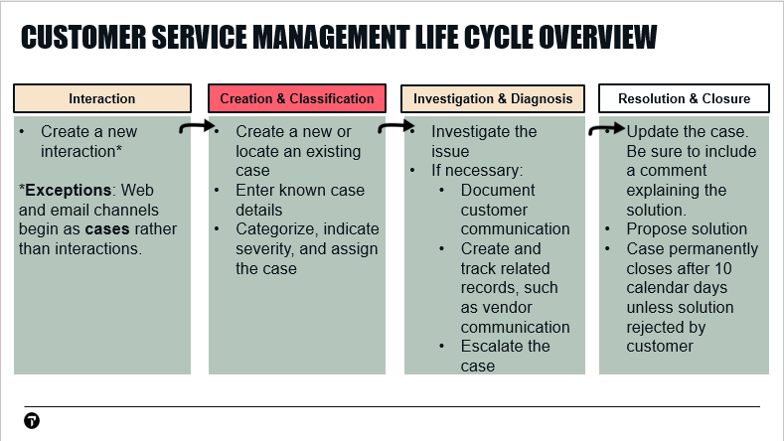

Here is the ServiceNow Case Life Cycle process we looked at earlier. The First Call Resolution cases we’ve been looking at up to now go from the New state directly to the Solution Proposed state. This is because the investigation can be handled by the agent on the first phone call.

A small percent of cases require more investigation and handling than this. For example, if you need to escalate the case to another help desk or reply to the customer to ask them for more information.

In the First Call Resolution, or FCR cases, we have looked at, the case workspace is simplified by removing options that aren’t needed for cases the agent creates and closes in one edit. Once a case has been saved, additional options are populated in the case workspace to help agents work cases that have more requirements.

Let’s look at the features ServiceNow offers to help you handle more complex cases.

|  |  |
| --- | --- |
|  | In ServiceNow, let’s view a case that’s in one of the Open statuses.  **Open** status means the case has been saved at least once. |

## Pending Statuses and other options for working with multi-touch cases

|  |  |
| --- | --- |
|  | At the top right-hand corner of the case workspace, we see some additional options:   * **Pending Internal** – select this status when you need to check with an internal person or group to assist with your investigation. * **Pending Vendor Info** – select this status when you need to check with a vendor, such as an airline, to assist with the case * **Request Info** – select this status when you need to request more information from the customer. While the case is in this status, if the customer fails to reply to the request in 10 calendar days, the case will permanently close. * **Compose email** – opens a dialog to send emails for this case. This option includes an option to copy someone on the email. If the copied person replies, the customer will be able to see their reply. * **Create Knowledge** – create a knowledge article * **Create Standard Change** – this option is used for development change management * **Propose Major Case** – Depending on the permissions for your ServiceNow profile, you may be able to create major cases. Major Case is a way to link cases that are caused by the same issue. * **Report Knowledge Gap** – Report a knowledge article that is missing information. |

## Request Info from Customer - DEMO

|  |  |
| --- | --- |
|  | When investigating a case, you will sometimes need to request additional information from the customer.  Let’s select an **Open** status case from a list so we can see how this process works. |
|  | From the 3-dots menu in the top right hand corner, select **Request Info**. |
|  | A message advises that we need to include an Additional Comment.  The Additional comment is where you will enter the message to the customer about what you are asking them. |
|  | Addan **Additional comment** with details of what we want to ask the customer. |
|  | Click **Request Info** again. |
|  | Our case is now in Awaiting Info status. |
|  | If the customer calls to answer your question, you would click **Open Case** to put the case back in Open status, then update the case with their reply.  If the customer replies from MyTravelport, the case will change to Open status and their case short description will have a blue highlight, when viewed in a cases list.  If the customer does not respond, the case will auto-close from Awaiting Info in 10 calendar days. (Weekends are included in this 10 day countdown.) |
|  | Sometimes, you will have a case in Pending Internal or Pending Vendor Info and you want to change it to another status. To do this, you must select **Open Case**, to put the case back in Open status.  Once the case is in **Open** status, you will then be able to select the other status. |

## Notes about case emails and attachments

|  |  |
| --- | --- |
|  | When using the **Compose Email** option under the 3-dots menu, be mindful that the customer will be able to see any replies to emails sent from this option. |
|  | For example, if I copy a vendor with this option they might reply with information that is only meant to be seen by the help desk.  However, the customer will be able to see their reply. |
|  | In the right toolbar, notice we have an attachments option. Customers can see any attachments from this option.  Later in this training, we will cover how to send emails and attach items so they are not visible to customers. |

## Tags – DEMO

Tags let you categorize cases so you can find them later.

|  |  |
| --- | --- |
|  | Once a case is saved, a **Tag** icon appears to the right of the case short description. |
|  | When we selectthe **tag** icon, a text field opens for us to enterthe desired text of the tag. |
|  | The tag icon changes color, to confirm the tag was added.  If we clickthe **tag** icon, we can see the tag we added.  “Me” means that I’m the only one who can see this tag. |
|  | Let’s viewanother case, so we can see how to apply our new tag. |
|  | Selectthe **tag** icon and begin **typing** the tag: **pnr**  A similar names list appears for me to select the tag I want to apply.  From the similar names list, select the **PNR** tag. |
|  | To see cases I’ve tagged, I need to switch to the **Platform UI** tag. |
|  | Let’s searchfor **tag**.  Next, we will selectthe **My Tagged Documents** list. |
|  | If I **select** thePNRtag, here is the case I was just working on.  I can open the case from here by clicking the case number. |

## Related Lists

Related lists display records in another table that have a relationship to the current case.

Note that the related lists do not appear until the case has been saved, and may appear as tabs or sections depending on your settings

## Related Lists – DEMO

1. Create an interaction, then create a new case. Apply a template to fill-in required fields. Save the case.
2. Scrolldown in the case workspace to locate the related list tabs.

|  |
| --- |
| Let’s walk through each of the tabs.   * **SLAs:** The service level agreements associated with this case. * **Tasks:** Tasks that have been created for this case. We will learn more about tasks shortly. * **Phone:** A list of incoming or outgoing phone calls associated with this case * **Appointments:** A list of appointments that the Agent makes with the customer or others as part of resolving this case. These appointments are not linked to Outlook or any other calendar program * **Emails:** A list of the emails that are sent or received as part of resolving this case. * **Related Cases:** A list of cases created for the same Account or Contact. These are an easy way to check if the issue the customer is reported has happened previously for their account or contact. * **Child Cases:** A list of child cases related to the current case. This functionality is now replaced by Major Case. We will learn about Major Case shortly. * **Attached Knowledge:** A list of any knowledge articles agents have attached as relevant to the case investigation * **Task Assessments:** This option was previously used for cases escalated to some groups. It is no longer used, but you may find it filled-in for older cases. * **Metrics:** A list of time cards documenting time worked on this case. It is used mainly for reporting. * **Interactions:** A list of interactions linked to the case. * **ScreenMeet Sessions:** The Help Desk uses ScreenMeet to view the customer’s screen, to assist with troubleshooting. ScreenMeet sessions for a case appear on this tab. |

We will take a closer look at the Task and Child Cases options next.

## Tasks – DEMO

**Instructor: it might be necessary to demo on prod, so the email will actually send.**

As noted previously, the attachment and email options that appear in the case workspace are both visible to customers.

For attachments and emails that cannot be seen by customers, we need to use Tasks.

Let’s begin by creating and saving a new case.

1. Create an interaction.
2. Create a new case.
3. Apply one or more templates to fill-in required fields.
4. Save the case.

|  |  |
| --- | --- |
|  | You may recall that if we add an attachment from the paperclip in the right toolbar for a case, the attachment will be visible to the customer.  If we want to add an attachment that only the help desk can see, we **cannot** add it here. |
|  | Likewise, if we send an email from the Compose Email option under the 3 dots menu in the case ribbon, the customer will be able to see replies to the email.  If we want to send an email for this case that the customer **can’t** see, such as an email to an airline, we **cannot** do that from this email option. |
|  | The place that we can add a private attachment to a case or send an email that the customer can’t see is from a **Task**.  Selectthe **Tasks** tab**.**  Once we have saved a case, Tasks are available on the **Tasks** tab. |
|  | To create a new task, select **New.** |
|  | The Task workspace opens. Notice we have a paperclip in the right toolbar.  Attachments you add here are **not** visible to the customer. Only the help desk can see attachments that are added in a task.  If you need to add an attachment that only the help desk can see, it should be added in the Task. |

The other use of Tasks is to send emails related to the case without the customer being able to see these emails. For example, you might use a Task to send emails to the sales manager for the customer’s account or to an airline or other vendor.

Let’s look at how Tasks are used to send emails.

|  |  |
| --- | --- |
|  | To enable the email option, we need to save the task. |
|  | Once the task is saved, a 3-dots menu appears in the top right-hand corner of the task.  From the 3-dots menu, select **Compose Email**. |
|  | A **New Email Draft** tab opens for us to fill-in the email.  **Cc**: is pre-filled with the help desk agent’s email.  **Subject** is pre-filled with the subject of the task. |
|  | In the **To:** field, we need to fill**-**in who the email should go to.   * If you need to send an email to the customer’s Account Manager, you can get that in ServiceNow > Accounts. * For airline email addresses, search MyTravelport for**: Airline Contact and the airline code.**   For example: **airline contact DL** |
|  | For this example, I’ll fill-inthe **To**: field with my personal email account.  I’m doing this so we can see the reply process that occurs when a vendor replies to the emails we send them. |
|  | Once I fill-in the verbiage of the email, I am ready to send it.  Click **Send** to send the email. |
|  | In another browser tab, display your email account.  I will checkmy emailso we can see the email that ServiceNow sent from the Task.  This is an example of the email the Account Manager or vendor would receive. |
|  | When I openthe email, I can see the text that I sent from ServiceNow. This is an example of what the vendor would see. |
|  | I’m replyingto the email, as the vendor or account manager would do.  Then, I will sendthe email. |
|  | Let’s switchbackto ServiceNow andviewour task.  In the Task > Activity area, I can see the vendor’s reply.  Because I sent my email from a task, the customer cannot see the email I sent or the vendor’s reply. |

### Reply to a vendor from a task

Occasionally, you will need to reply to a vendor’s email. The process for replying to a vendor’s email is a little different than the initial email.

|  |  |
| --- | --- |
|  | Once you have emailed a vendor from a Task, ServiceNow automatically adds the vendor’s email to the **Work notes list** field for the Task.  If you need to send another email to the vendor for this task, all you need to do is add a **Work Note** to the Task and **save** the Task.  Because the vendor’s email is in the **Work notes list**, ServiceNow sends them an email anytime a work note is added to the Task.  Please do not use the **Compose email** option to reply to the vendor because it can cause them to receive duplicate emails. Compose email should only be used for the **first** email sent from a Task. |

### Contact multiple vendors from a Task

|  |  |
| --- | --- |
| **DO**:    **DON’T**: | If you need to contact more than one airline for a case, create a **separate** **task** for each airline.  It’s fine to have multiple tasks linked to a case.  Do **not** contact multiple airlines from the **same** task because it can cause the airlines to receive duplicate emails or emails meant for other airlines. |

## Review: Tasks - SLIDE 25

**Instructor: it might be necessary to demo on prod, so the email will actually send. If it’s necessary to demo on production, be sure to use an internal CIDB and a test contact.**

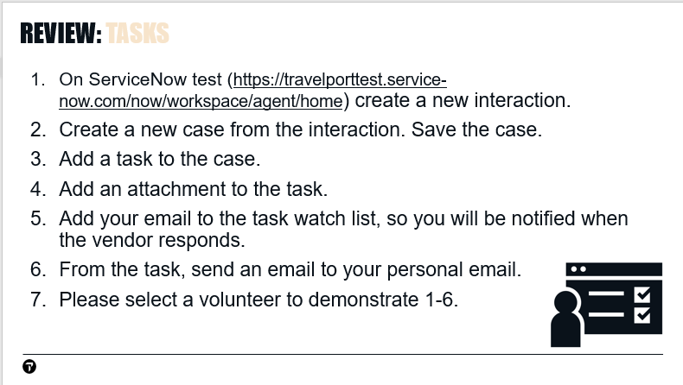

## Major cases – SLIDE 26

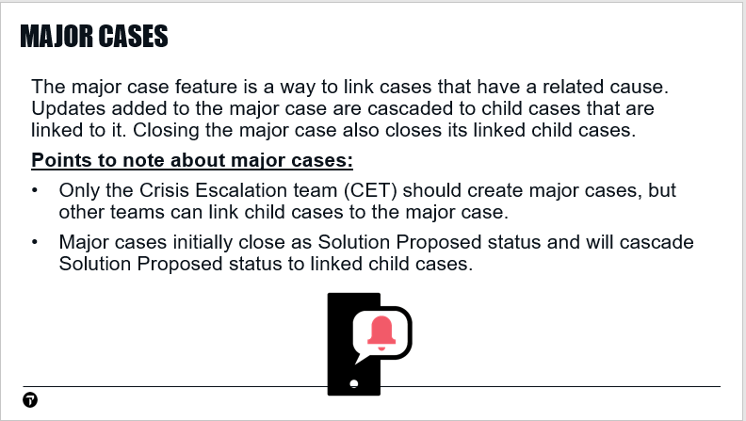

## Major case – DEMO

|  |  |
| --- | --- |
|  | Let’s begin by creating and saving a new case:   1. Create an interaction. 2. Create a new case. Apply templates to fill-in required fields. 3. Save the case. |
|  | Let’s assume the issue in our case is related to an existing major case.  To viewmajor cases that are Open status, select **Lists** > **Major Issue Management** > **Open** |
|  | From the list of Major cases in Open status, we can previewa case to make sure it’s the one we want to link to. |
|  | Copythe major case number from the preview. |
|  | Pastethe major case number in the Parent field for your child case.  Save your child case. |
|  | A pop-up confirms our case is now linked to the major case. |

When the Crisis Escalation Team updates the major case, the update is cascaded to the linked child cases.

When the Crisis Escalation Team proposes solution on the parent, the linked child cases will also go to Solution Proposed status.

|  |  |
| --- | --- |
|  | On the major case Details tab > Notes area, notice the notification options:   * To receive a notification email when a **comment** is added to the major case, add your email to **Watch list**. * To receive a notification email when a **work note** is added to the major case, add your email to the **Work notes** list. |

## Major Case - eLearning

Time estimate to complete this eLearning: 6 minutes

## Case Life Cycle: Resolution and Closure – SLIDE 27

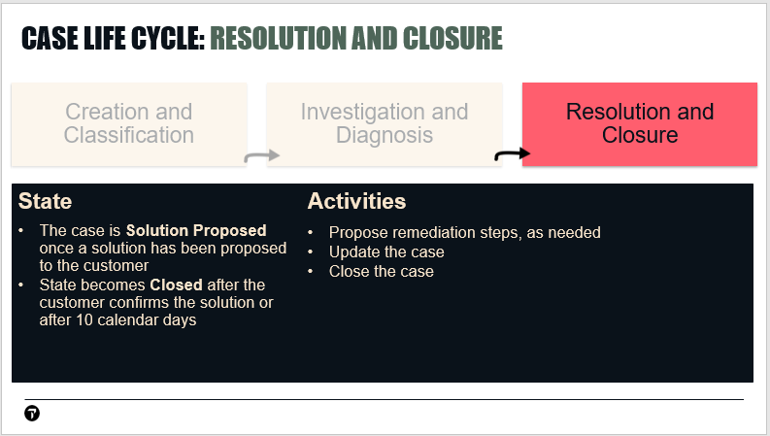

During Resolution and Closure, the case is in a Solution Proposed state.

The state becomes **Closed** after the customer confirms the solution or after 10 calendar days

## Propose a Solution – SLIDE 28

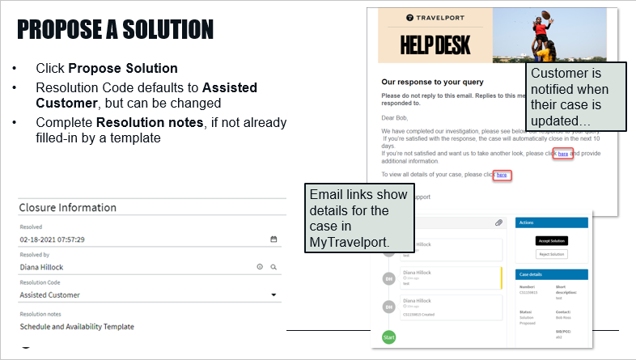

When you have resolved a customer’s issue, select the **Propose Solution**. At this point, the **Resolution Code and Resolution Text** that document the resolution, are required. The Resolution Code defaults to **Assisted Customer**, but can be changed by the help desk agent.

If you used a template, the **Resolution Text** is filled-in for you. Please do not make changes to Resolution Text filled-in by a template.

The Resolution Text field is not visible to the customer, so make sure to update **Additional Comments** when you Propose Solution on a case, so the customer will know what the solution was.

The customer is notified by an email when solution is proposed on a case. They select the **click here** link in the email to view the case in MyTravelport.

## Closure – SLIDE 29

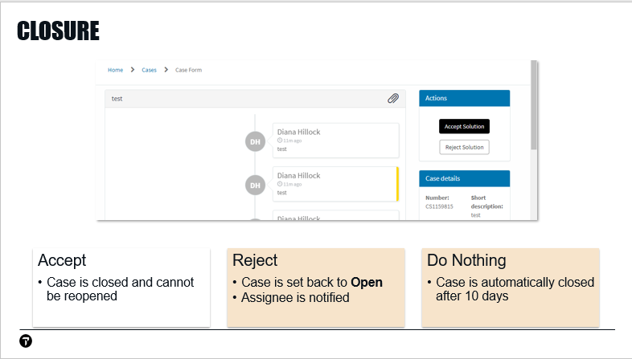

If the customer views their case in MyTravelport while it is Solution Proposed, they will see a screen similar to this.

At this point, the customer can do one of three things:

**Accept Solution:** The case is closed and cannot be reopened.

**Reject Solution:** The case is set back to an **Open** State and assigned to the group and agent that closed it. The Customer can also enter comments, if needed.

**Do Nothing:** The case is automatically closed 10 calendar days after a solution is proposed.

# Call Handling Best Practices

**Instructor: Walk through the steps in Call Handling Best Practices attachment at KB0013339 with students.**

These are processes Travelport has setup that will help you work calls quicker and more accurately. You may wish to print out a copy of these best practices for call handling to refer to as you begin working calls.

# References – SLIDE 30

Let’s look at some knowledge base references that can assist you when working in ServiceNow.

